福壽雙禧 | 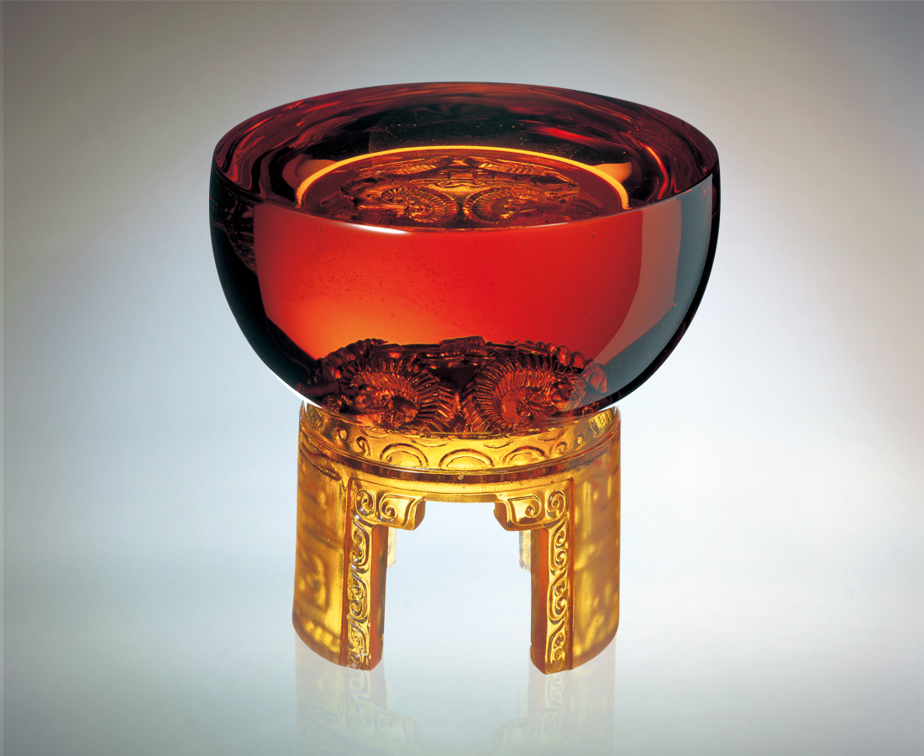
天 高照
心領神會 攜手
撐起如影隨形的熱情
天 無雲
晶瑩剔透 輝映
心思細膩的曼妙福壽
情意夢
一諾千金而長長久久
Happiness and Longevity
With sky high up, perfect understanding leads to unity, while spurring up great zest. The cloudless sky, appears transparent and bright. The delicate happiness and longevity, bring the sentimental dream into reality. Promise can last forever.

編號 | 1442019 | No | 1442019
名稱 | 福壽雙禧 | Name | Happiness and Longevity
顏色 | 琥 | Color
尺寸 | 9.1 * 9.1 * 8.5 | Size | 9.1 * 9.1 * 8.5
重量 | 0.9 | Weight | 0.9
限量 | X | Limited Edition | X
售價 | NT$ 6280 | Price | NT$ 6280
 | RMB$ 1566 |  | RMB$ 1566

