氣派鼎盛 | 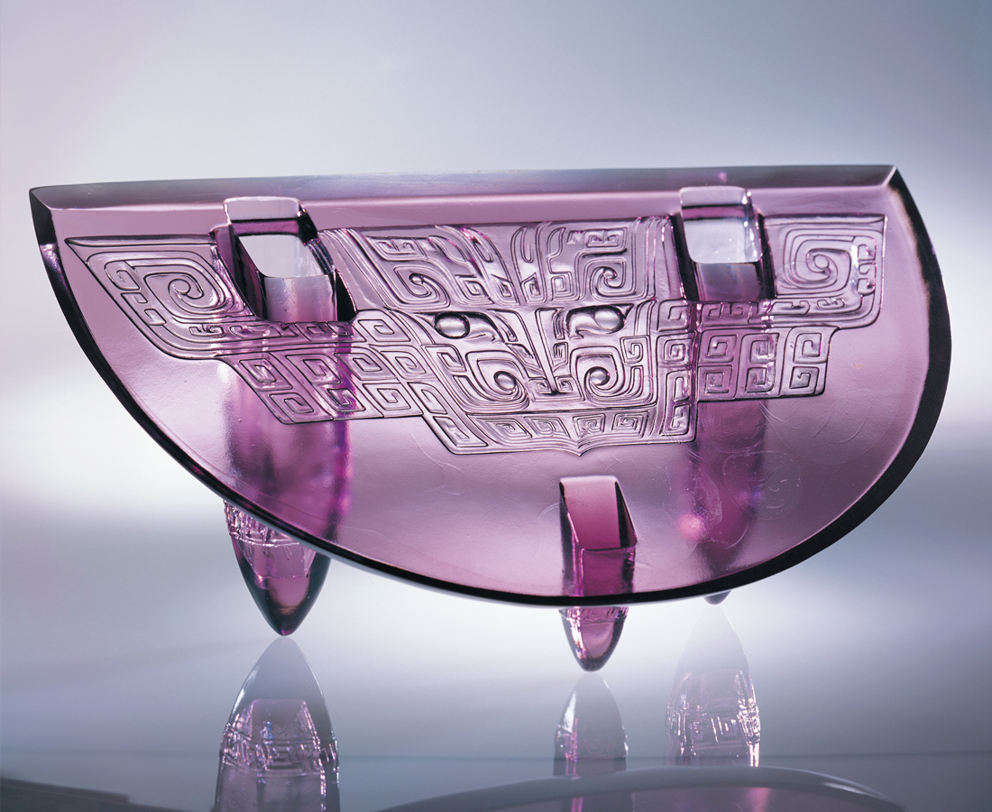
挺身 砥柱 正色
緊守方寸此立錐之地
展演正氣浩然的氣派
而就此立德立言立功
Soaring Magnificence
Standing up as the mainstay with uprightness, While firmly keeping the stronghold. Displaying upright magnificence, While rendering meritorious services.

編號 | 1441073 | No | 1441073
名稱 | 氣派鼎盛 | Name | Soaring Magnificence
顏色 | 紫 | Color
尺寸 | 22.8 * 50.4 * 24.8 | Size | 22.8 * 50.4 * 24.8
重量 | 11.98 | Weight | 11.98
限量 | O | Limited Edition | O
售價 | NT$ 268000 | Price | NT$ 268000
 | RMB$ 66988 |  | RMB$ 66988

