佳偶蓮成 | 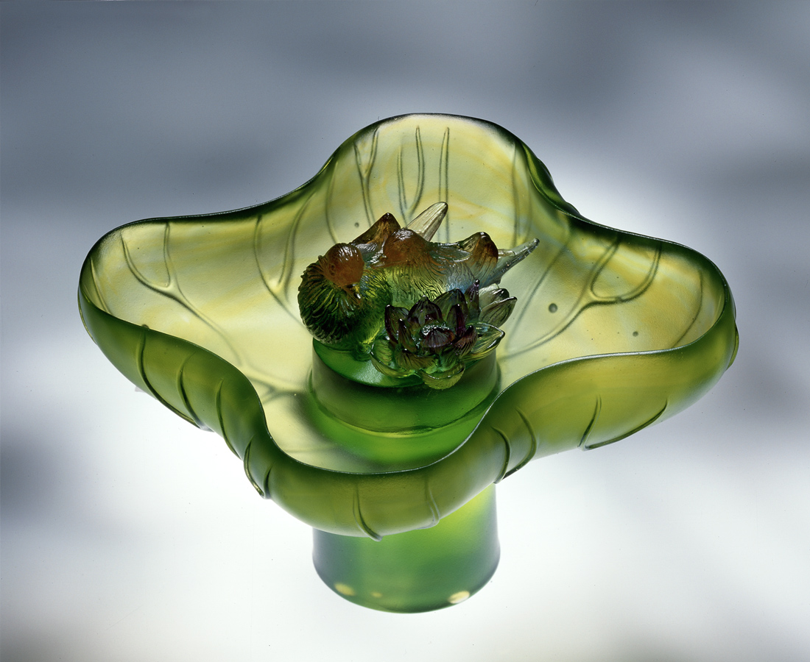
在荷塘形影相隨
用體諒欣賞池中美景
用信任悠遊花間芬芳
彼此關懷 相互提攜
看著花開 純然依偎
看著結果 了然自得
渾然美滿中
不知蓮成佳藕或是佳偶聯成
The Lotus-joined Couple
Clinging together in the lotus pond Using understanding to enjoy the beauty of the pond Using trust to drift among the fragrance of the flowers Shared concern Mutual help Watching flowers bloom Snuggling together Seeing them bear fruit Plainly satisfied In this completely natural happiness Is it a perfect lotus root or just a perfect couple.

編號 | 1416024 | No | 1416024
名稱 | 佳偶蓮成 | Name | The Lotus-joined Couple
顏色 | 藍綠琥紫透 | Color
尺寸 | 18.8 * 18.8 * 12 | Size | 18.8 * 18.8 * 12
重量 | 1.6 | Weight | 1.6
限量 | O | Limited Edition | O
售價 | NT$ 21200 | Price | NT$ 21200
 | RMB$ 4720 |  | RMB$ 4720

