旺旺來 | 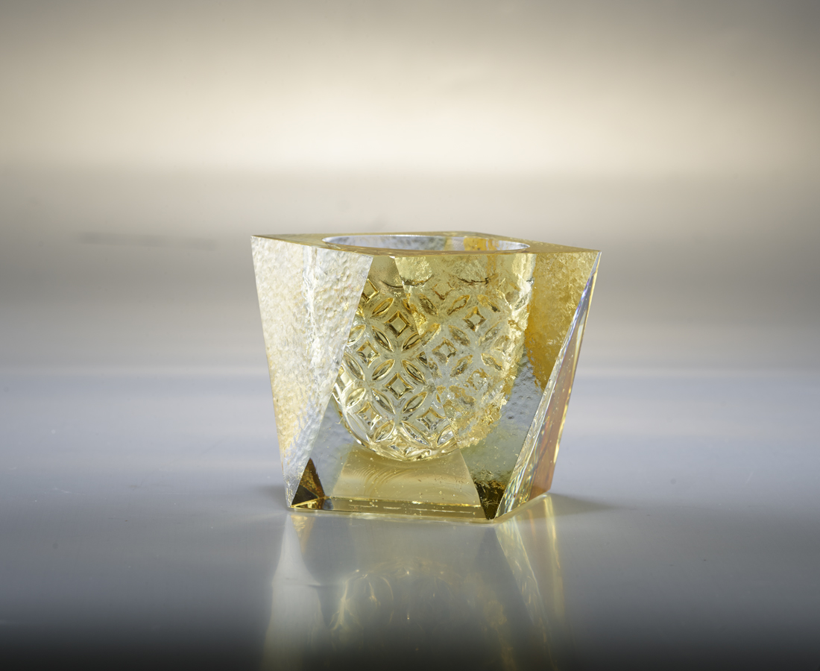
深度
來自深刻的耕耘
結成
好運旺來的果實
Pineapple Treasure Bowl
Its clear geometric shape adds a subtle touch to the exquisite coin patterns. It is a manifesto of Tittot’s 20 years of superb craftsmanship. The golden color resembles the ripening and tasty pineapple. This art piece is meant to encourage everyone to accumulate experience and strength and finally acquire sweet and bountiful fruits.

編號 | 1413549 | No | 1413549
名稱 | 旺旺來 | Name | Pineapple Treasure Bowl
顏色 | 琥透 | Color | amber, clear
尺寸 | 10.3 * 7.5 * 8 | Size | 10.3 * 7.5 * 8
重量 | 0.76 | Weight | 0.76
限量 | X | Limited Edition | X
售價 | NT$ 3480 | Price | NT$ 3480
 | RMB$ 780 |  | RMB$ 780

