節節高 | 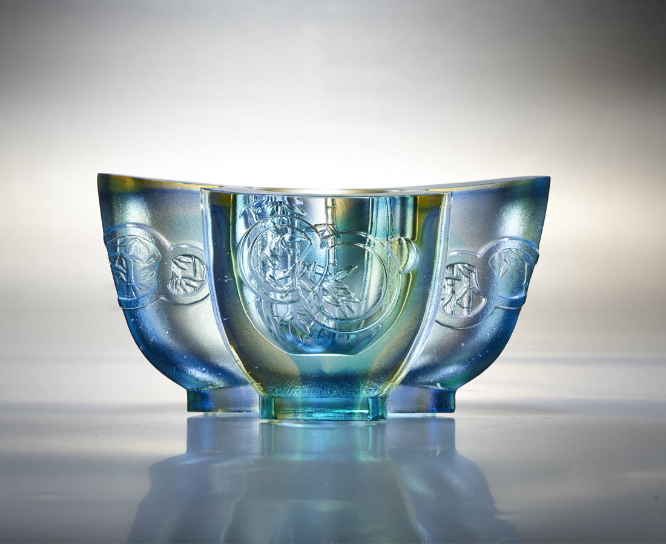
拉開東南西北的視野
順著按部就班的節奏
下一步
就是高陞不已的鴻圖
Bamboo Treasure Bowl
Tittot combines the shapes of bamboo and ingot together into this art piece. The continuously growing bamboo symbolizes the idea that the accumulation of strength will lay the foundation for success.

編號 | 1413547 | No | 1413547
名稱 | 節節高 | Name | Bamboo Treasure Bowl
顏色 | 藍青琥透 | Color | blue ,cyan ,amber ,clear
尺寸 | 19 * 8.6 * 10.2 | Size | 19 * 8.6 * 10.2
重量 | 1.7 | Weight | 1.7
限量 | X | Limited Edition | X
售價 | NT$ 8280 | Price | NT$ 8280
 | RMB$ 1840 |  | RMB$ 1840

