富貴芬芳 | 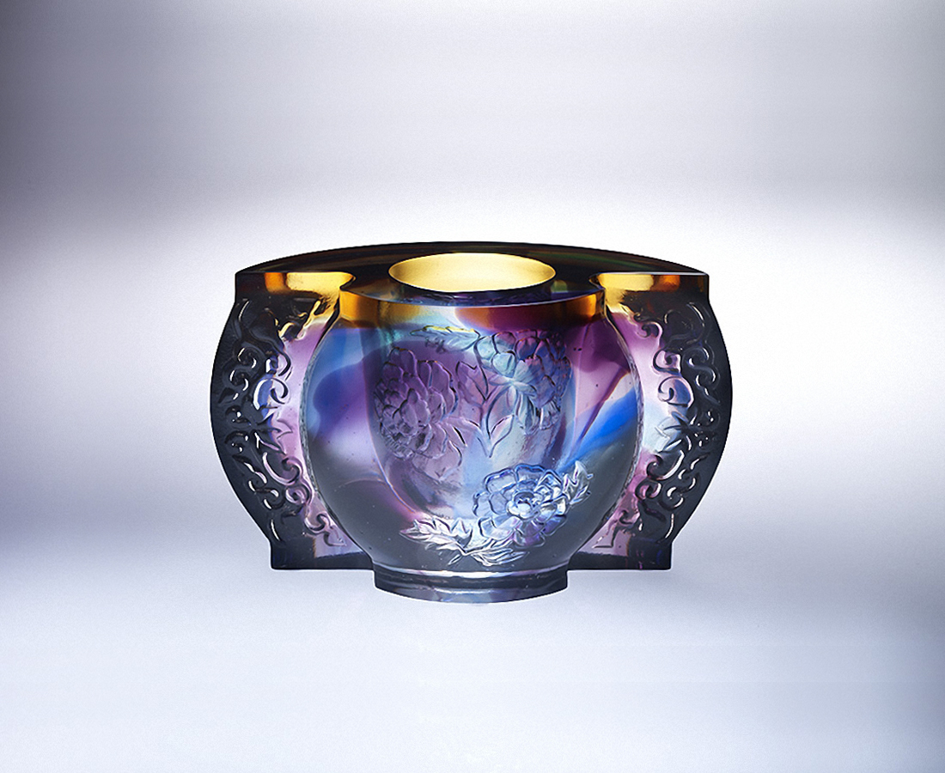
朝四面八方探索
漸入富貴天成佳境
向澄澈無瑕深入
綻放心想事成芬芳
Peony Treasure Bowl
Peony, a symbol of wealth in Chinese culture, is incorporated by Tittot into the body of this art piece. With patterns of flourishing flowers and plants, this art piece stands for vitality and a forward momentum, wishing everyone can make life better and richer.

編號 | 1413546 | No | 1413546
名稱 | 富貴芬芳 | Name | Peony Treasure Bowl
顏色 | 藍琥紫青透 | Color | blue, amber, purple, cyan, clear
尺寸 | 15.5 * 6.5 * 9.5 | Size | 15.5 * 6.5 * 9.5
重量 | 1.55 | Weight | 1.55
限量 | X | Limited Edition | X
售價 | NT$ 7880 | Price | NT$ 7880
 | RMB$ 1760 |  | RMB$ 1760

