夏荷坦然 | 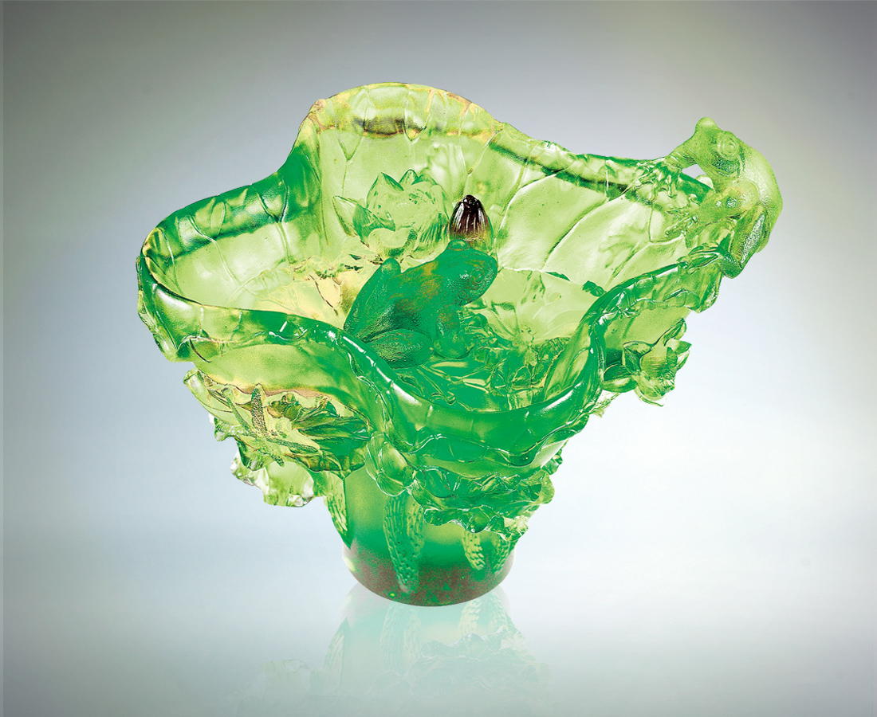
誰也躲不掉炙亮的檢視
豔陽下層層攤開
開誠佈公 光明磊落
夏天是一種態度
無論身處何種情境
自我真實評量
清楚出發的定位
而開花 而行動
Tranquility of Summer Lotuses
No one can evade the burning, brilliant gaze; Layer after layer unfolds under the luminous sun; Be frank and sincere, straightforward and upright; Summer is a kind of attitude; No matter what circumstances you are in, Make a truthful assessment of yourself; Be clear about your starting point, And bloom, and move.

編號 | 1409249 | No | 1409249
名稱 | 夏荷坦然 | Name | Tranquility of Summer Lotuses
顏色 | 琥綠透 | Color
尺寸 | 17.3 * 17 * 15.2 | Size | 17.3 * 17 * 15.2
重量 | 2.9 | Weight | 2.9
限量 | X | Limited Edition | X
售價 | NT$ 18800 | Price | NT$ 18800
 | RMB$ 5088 |  | RMB$ 5088

