冬梅精練 | 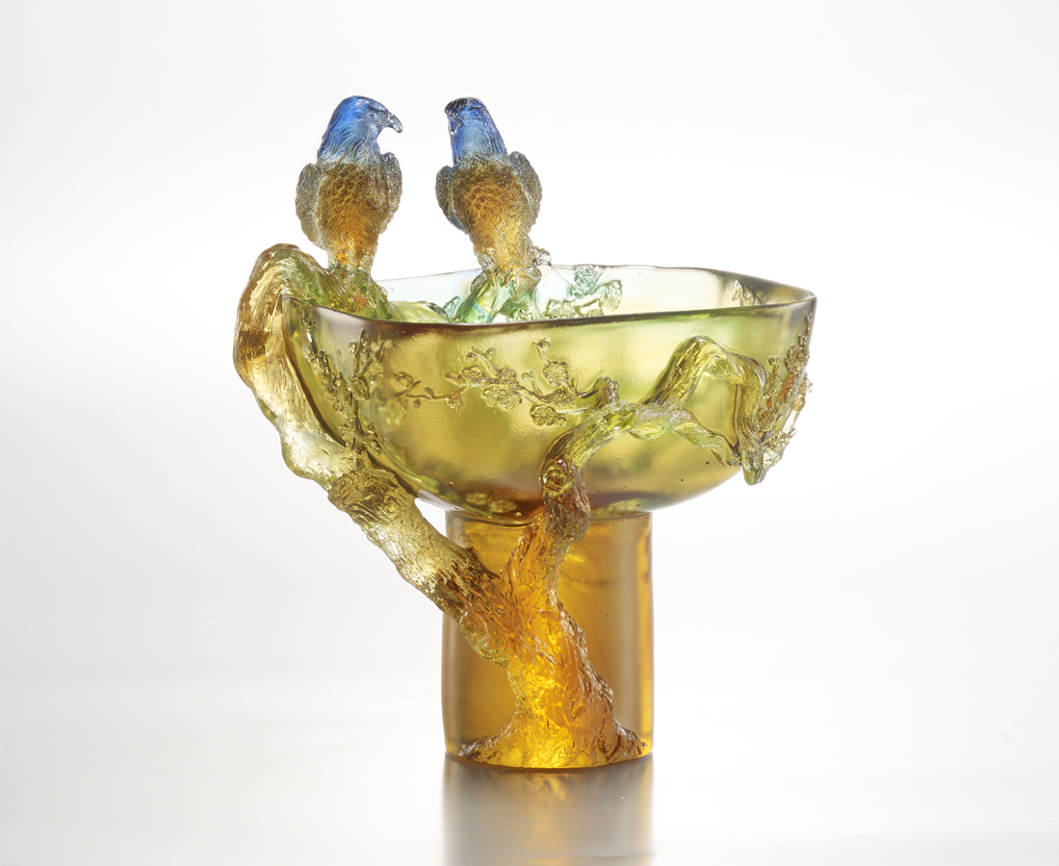
如冬蟄伏 深刻思索
似梅蒼勁 穩重精練
盤繞再三 來回斟酌
周密是勝出的法則
冬天是一種態勢
感性支撐方正規矩的運作
精準理性的標設新方向
Winter Plum's Refinement
As if in hibernation, a moment of profound thought; Like the hale and hearty plum, in solemn refinement; Circling again and again, contemplating back and forth; Attention to detail is the first rule of victory. Winter is a kind of posture; The action of the emotionally-propped straight rule Precisely marks out a new direction.

編號 | 1409248 | No | 1409248
名稱 | 冬梅精練 | Name | Winter Plum's Refinement
顏色 | 藍紫透 / 藍綠透 | Color | null
尺寸 | 14.7 * 16.8 * 19.8 | Size | 14.7 * 16.8 * 19.8
重量 | 1.95 | Weight | 1.95
限量 | O | Limited Edition | O
售價 | NT$ 19600 | Price | NT$ 19600
 | RMB$ 5388 |  | RMB$ 5388

