春水奔騰 | 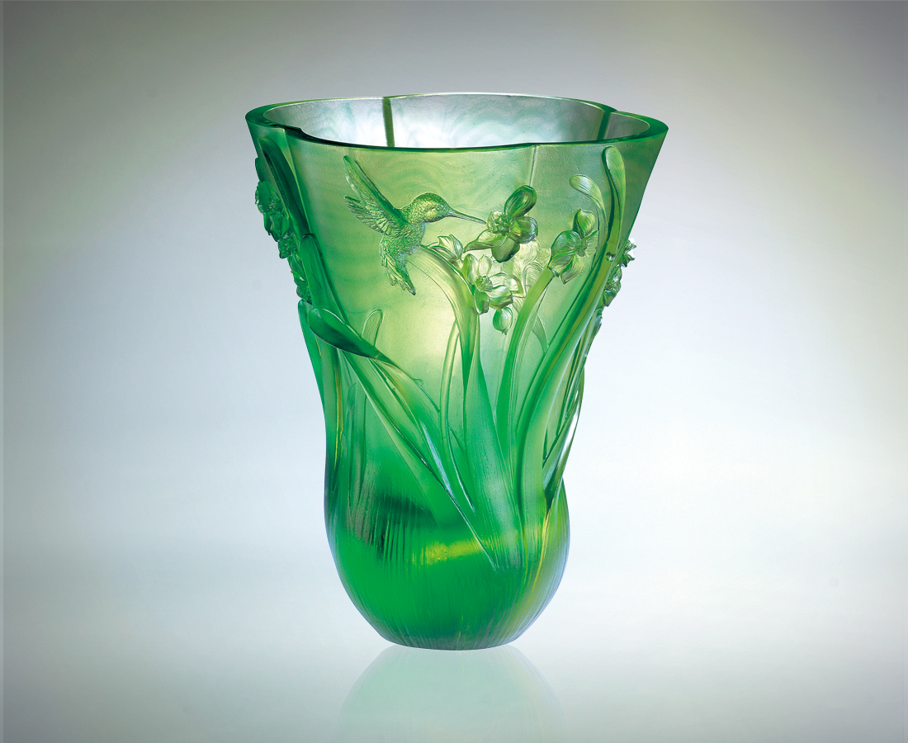
陽光見證花香的朝氣
綠意聆聽鳥語的振奮
綻放拔高 張翅穿梭
生機分秒不停
春天是一種創造
奔飛是唯一的動作
希望在芬芳昂然中
爭先恐後 一刻都不停
Tumbling Springtime Water
Flowers blooming profusely in the warm sunshine Birds frolicking and singing sweetly in the trees Reaching into the skies, spreading their wings Life pulsates everywhere Spring is a season of creation Made visible only by flying Spreading hope amidst the bustling fragrance Always striving to be ahead, never stopping for one moment

編號 | 1409005 | No | 1409005
名稱 | 春水奔騰 | Name | Tumbling Springtime Water
顏色 | 金綠 | Color
尺寸 | 14.8 * 15.5 * 17.9 | Size | 14.8 * 15.5 * 17.9
重量 | 1.8 | Weight | 1.8
限量 | O | Limited Edition | O
售價 | NT$ 18900 | Price | NT$ 18900
 | RMB$ 5188 |  | RMB$ 5188

