同心同意 | 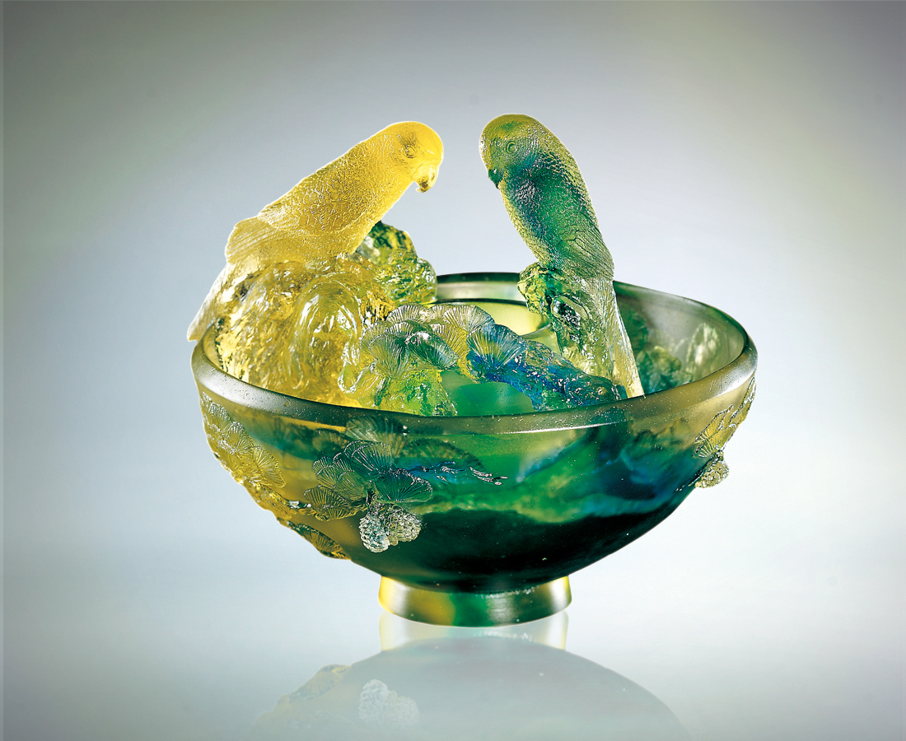
同心圓的形成
是偶然？是必然
從不經意棲息的同心
至地老天荒糾結的同意
心緒搖擺時有濃密稀疏
但期許如老松
與大自然環境的互動
在對峙在順勢的相處
了然共生的真諦
而見曲折蒼勁的深刻
也見甜蜜常青的因緣
With the Same Heart and Mind
Is the formation of concentric circles an accident? They inevitably appear from hearts that inadvertently settle in the same place. As for long-bound consent A quivering mood that thickens and thins But we hope like the old pine To interact with the natural environment Confronted in a favorable relationship Completing the essence of coexistence Leaving the deep impression of seeing the tenacious strength And the affinities of seeing the sweet greenery

編號 | 1408016 | No | 1408016
名稱 | 同心同意 | Name | With the Same Heart and Mind
顏色 | 金藍綠 | Color
尺寸 | 21 * 19.5 * 17 | Size | 21 * 19.5 * 17
重量 | 4.0 | Weight | 4.0
限量 | O | Limited Edition | O
售價 | NT$ 45600 | Price | NT$ 45600
 | RMB$ 10688 |  | RMB$ 10688

