平安 | 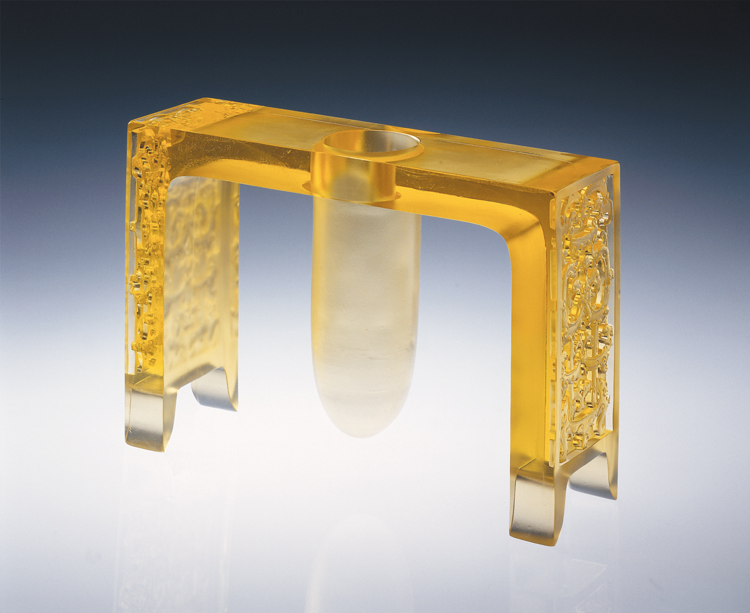
平是無限延伸的寧靜張力
安是恰如其份的堅忍支撐
平安就是福 它是
水平垂直完美的轉捩點
它在拉拒折衝間平衡
在古今中外象限的經緯上
有最豐富的傳統訊息
有最精準的摩登態度
在古典與現代氣氛裡
呈現平穩安靜的和諧
Safety
Flatness is limitless silent elasticity Peace is just the right amount of determined support Safety is good fortune The perfect axis of horizontal and vertical It keeps balance despite being pulled to and fro On the latitude and longitude of yesterday and today, in China and overseas Is the most abundant traditional information There is the most precise modern attitude From the classic and modern atmosphere Emerges steady and peaceful harmony

編號 | 1406087 | No | 1406087
名稱 | 平安 | Name | Safety
顏色 | 金 | Color
尺寸 | 9 * 26.8 * 30.2 | Size | 9 * 26.8 * 30.2
重量 | 5.5 | Weight | 5.5
限量 | O | Limited Edition | O
售價 | NT$ 79800 | Price | NT$ 79800
 | RMB$ 19966 |  | RMB$ 19966

