三春暉 | 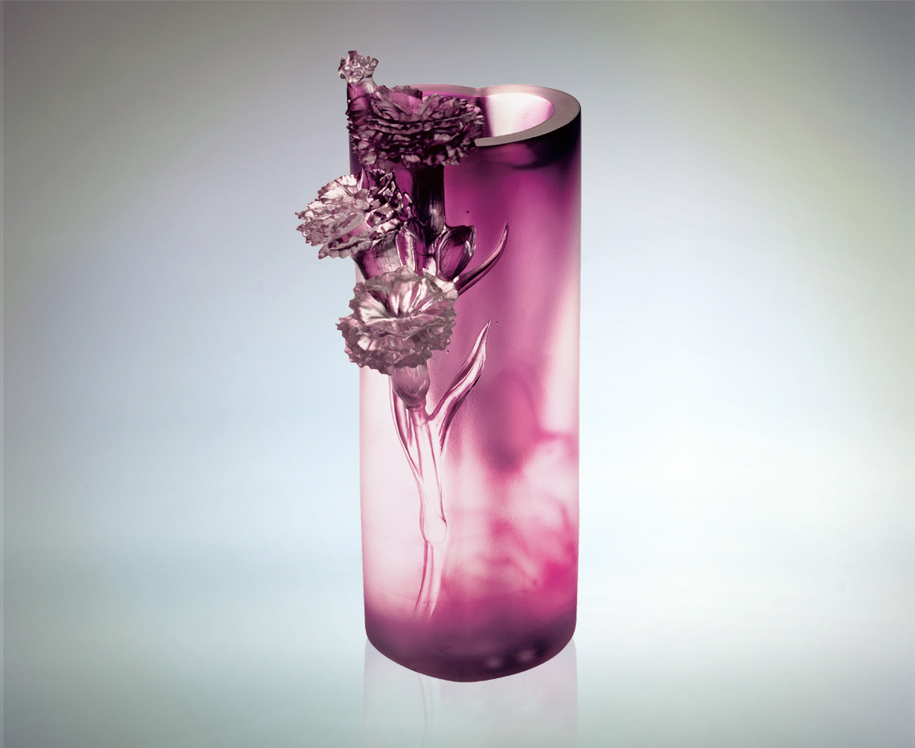
誰言寸草心
報得三春暉
無數個春天後
你還記得多少
這人間至高而無所求的關愛
這帶給你我信心、暖溫的情愫
杯枯竭的光暉
像瓶中永遠綻放的康乃馨
手握它 親愛母親
也謹記這至美的芬芳而珍惜
A mother's love
But how much love has the inch-long grass, for three spring months of the light of the sun? After the passing of innumerable spring days, how much will you remember? The most sublime passion in this life is a mother‘s unconditional love that bestows confidence and warms us to our innermost essence. Its inexhaustible radiance; like the immortal carnation, perpetually blooming in its vase. As I grab the flower, dearest mother, cherishingly contemplate its exquisite fragrance.

編號 | 1405020 | No | 1405020
名稱 | 三春暉 | Name | A mother's love
顏色 | 紫透 | Color
尺寸 | 11 * 7.8 * 24 | Size | 11 * 7.8 * 24
重量 | 2.4 | Weight | 2.4
限量 | O | Limited Edition | O
售價 | NT$ 26800 | Price | NT$ 26800
 | RMB$ 0 |  | RMB$ 0

