鳴粒雙收 | 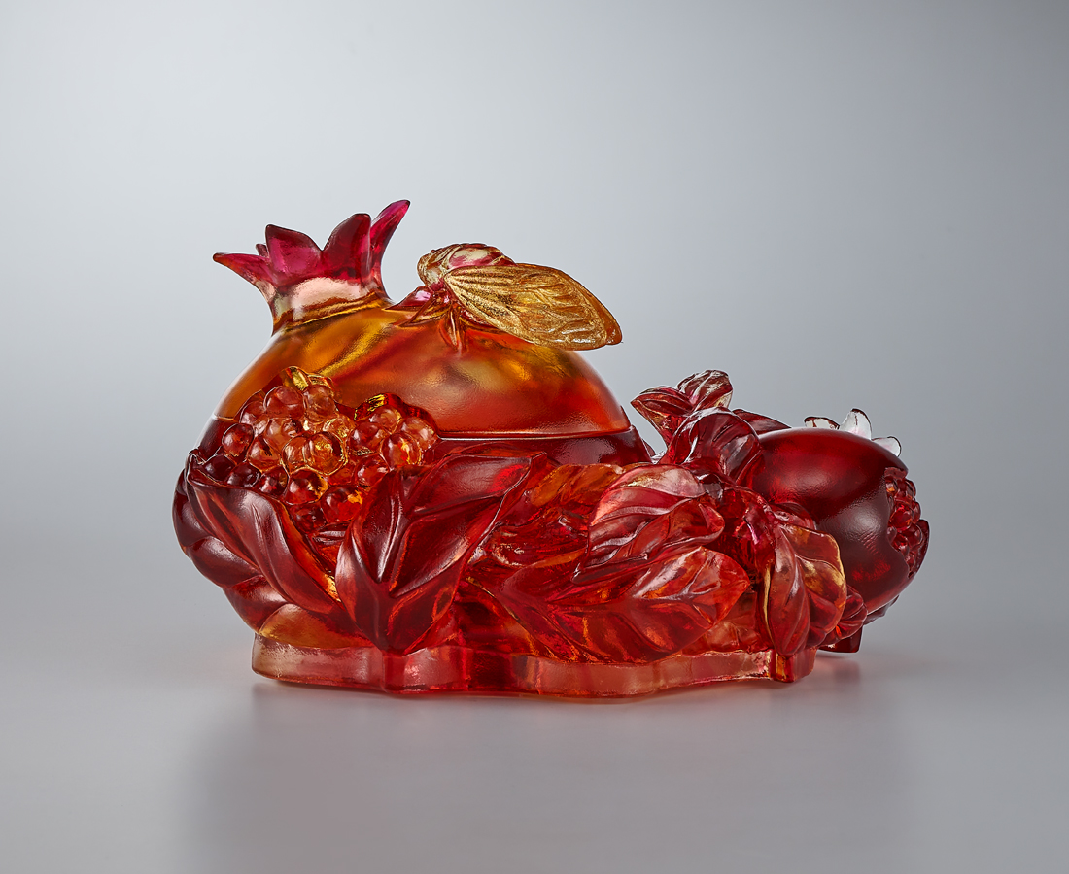
蟬聲出林散 佳鳴留千載
榴熟金珠解 富粒永珍藏
心隨緣行 自然莫擾
順勢遞代 名利雙收
Summer Cicada and Autumn Pomegranate
The design of this item is inspired by the National Palace Museum’s collection “Jade water holder in the shape of a pomegranate, Qing dynasty”. In ancient Chinese art creations, it is very common to see pomegranates and cicadas paired together as a theme. The cicada represents the life of summer, and together with the pomegranate harvested in autumn, it represents the meaning of succession. In addition, the pomegranate represents the blessing of family prosperity.

編號 | 1404115 | No | 1404115
名稱 | 鳴粒雙收 | Name | Summer Cicada and Autumn Pomegranate
顏色 | 琥紅透+金箔 | Color | amber, red, clear and gilding
尺寸 | 14.1 * 13.7 * 8.8 | Size | 14.1 * 13.7 * 8.8
重量 | 1.23 | Weight | 1.23
限量 | O | Limited Edition | O
售價 | NT$ 14800 | Price | NT$ 14800
 | RMB$ 3300 |  | RMB$ 3300

