鴻鱗運轉 | 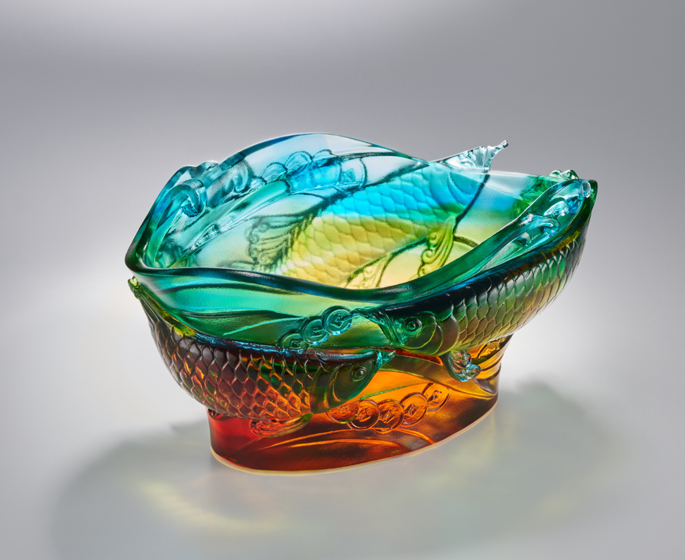
年來見潛鱗
鱗耀立昇龍
龍行盛鴻運
運轉千萬年
The endless cycle of wealth
The red dragon fish, native to Asia, has elegant and noble figures and elegantly colored scales, therefore, under the influence of Chinese dragon culture, it has become an embodiment of good fortune and symbolizes wealth and prosperity, which is a popular theme for display in many people's homes. The image of a dragon fish in the living water, together with the emblematic air bubbles of a coin, is used to bless the collector with the best of luck.

編號 | 1404087 | No | 1404087
名稱 | 鴻鱗運轉 | Name | The endless cycle of wealth
顏色 | 琥綠青透 | Color | amber, green, cyan, clear
尺寸 | 21 * 12.7 * 11.4 | Size | 21 * 12.7 * 11.4
重量 | 2.51 | Weight | 2.51
限量 | O | Limited Edition | O
售價 | NT$ 17800 | Price | NT$ 17800
 | RMB$ 3980 |  | RMB$ 3980

