祿鹿大順 | 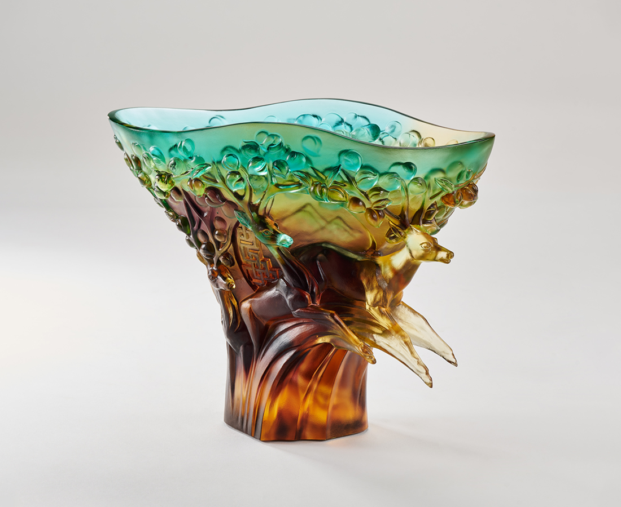
坐擁福地 滿腹甘旨
吟詠書畫 隨心所欲
妙語切磋 頂灌醍醐
昂角抖擻 縱身頃刻
凌雲昇華 無我通達
放眼六合 祿鹿大順
Embracing Success
In Chinese, the pronunciation of deer is the same as "祿 (Lu)," while its graceful and upright image is very popular among people. In this bowl-shaped piece, the six deers can be seen in a circle, gradually rising and leaping in a continuous movement. In addition, the angles are transformed into a large fruit-bearing tree, symbolizing the bountiful harvest that will come from hard work and breakthroughs.

編號 | 1404086 | No | 1404086
名稱 | 祿鹿大順 | Name | Embracing Success
顏色 | 金青茶紫透 | Color | golden, cyan, brown, purple, clear
尺寸 | 22 * 11.5 * 18 | Size | 22 * 11.5 * 18
重量 | 3.0 | Weight | 3.0
限量 | O | Limited Edition | O
售價 | NT$ 25800 | Price | NT$ 25800
 | RMB$ 5780 |  | RMB$ 5780

