蕙質蘭心 | 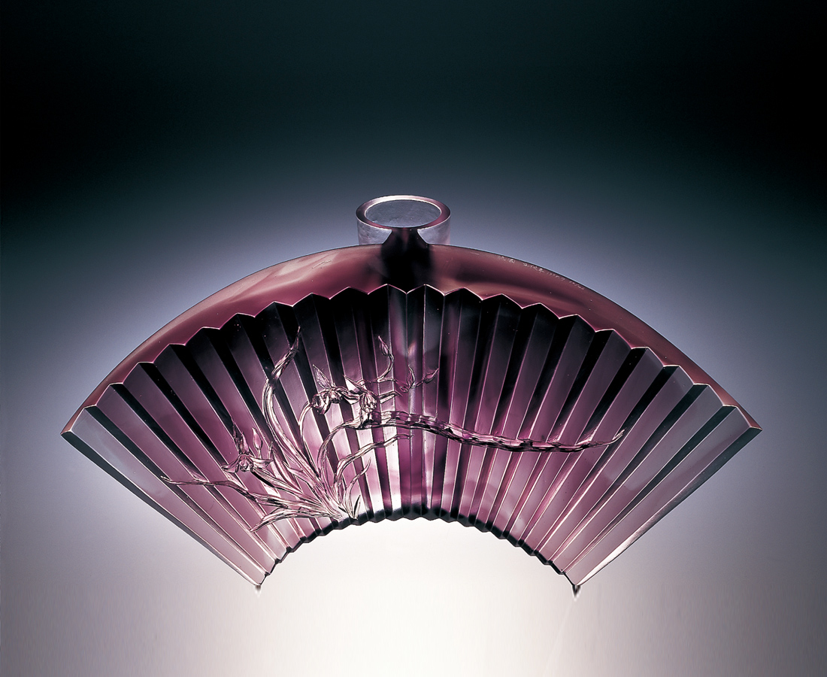
打開扇
輕搖一室 幽蘭的清香
王者之香 繞樑不絕
展開扇
點妝一角 蕙質的景色
沉靜色影 靈氣逼人
蘭花的心 秀美飄逸節次分明
玻璃的心 剛柔並濟明亮堅實
蕙質蘭心
純美矜持 倚立不搖
A Flower of Grace and Virtue
Open a fan The delicate fragrance of on orchid A grand fragrance floating without end A spreading fan In one corner a good and pure scene A quiet and calm image, a spiritual air pressing in on you An orchid heart, graceful, elegant with natural grace, clearly delineated A glass heart, firm, elegant bright and shinning A Flower of Grace and Virtue Pure and beautiful, restrained and reserved, steady and unshakable

編號 | 1404026 | No | 1404026
名稱 | 蕙質蘭心 | Name | A Flower of Grace and Virtue
顏色 | 紫透 | Color
尺寸 | 16.3 * 44.7 * 22 | Size | 16.3 * 44.7 * 22
重量 | 9.1 | Weight | 9.1
限量 | O | Limited Edition | O
售價 | NT$ 167800 | Price | NT$ 167800
 | RMB$ 45488 |  | RMB$ 45488

