日正當中 | 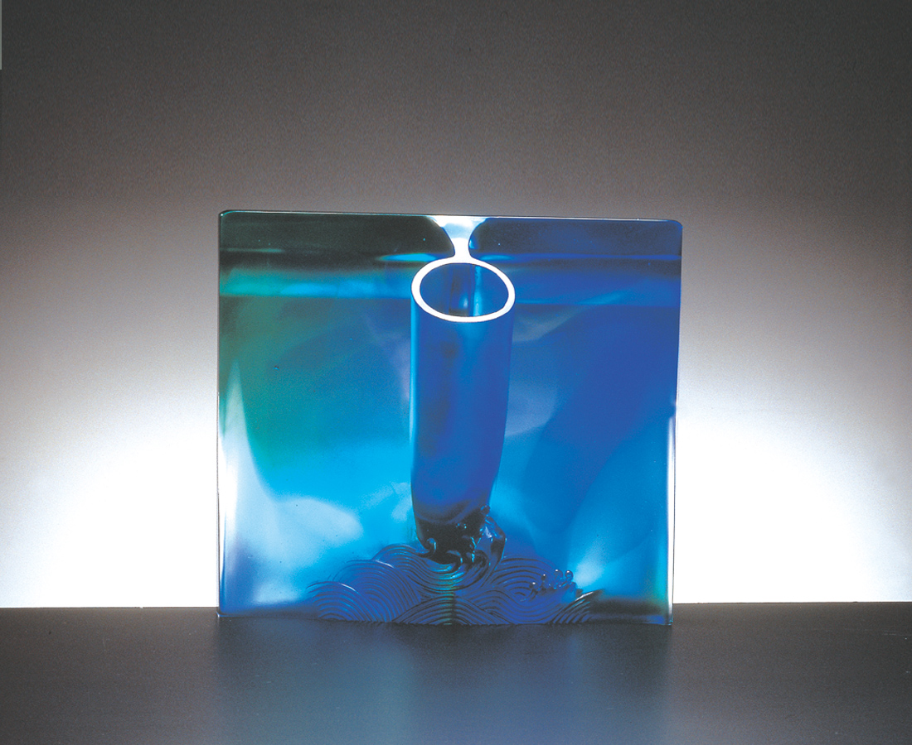
人生像一幕舞台
上上下下 進進出出
在如海水潮汐的變奏裡
喜怒哀樂 高高低低
成就失意 起起落落
當樂聲響起 浪花湧現
就是這個時候
旱地拔蔥 挺身而起
就是你 日正當中 光芒萬丈
人生情節和節奏
High Noon
Life is like a stage, we appear, we depart. Life is as the variations in the morning and evening tides. The music rises, the waves appear in large number. At that moment one must grasp the opportunity. Life‘s circumstances and rhythms are in your grasp.

編號 | 1404025 | No | 1404025
名稱 | 日正當中 | Name | High Noon
顏色 | 藍綠透 | Color
尺寸 | 12 * 30 * 26.8 | Size | 12 * 30 * 26.8
重量 | 7.7 | Weight | 7.7
限量 | O | Limited Edition | O
售價 | NT$ 98200 | Price | NT$ 98200
 | RMB$ 26588 |  | RMB$ 26588

