福祿圓滿 | 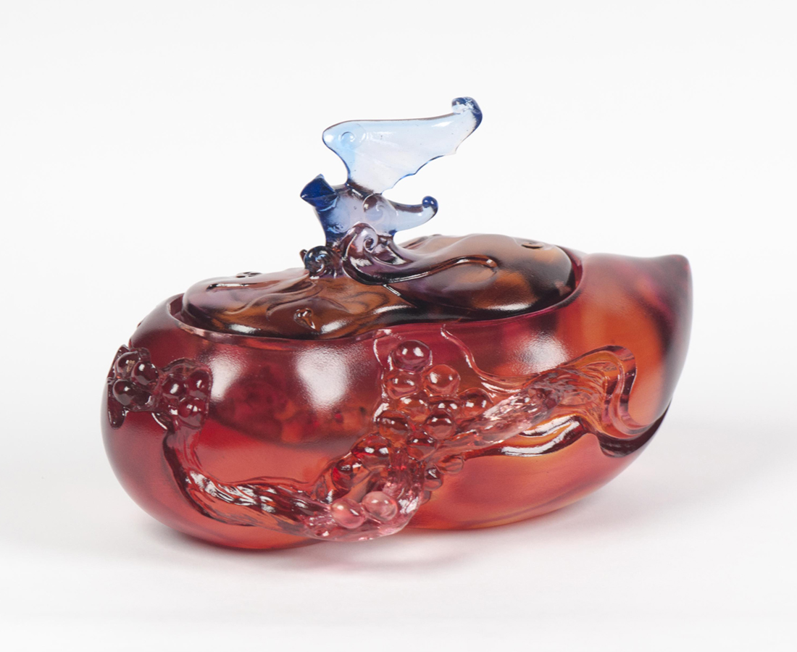
飛福臨門 大吉大利
日日如意豐收
天祿盈戶 財源廣進
年年圓滿高昇
Abundance of Fortune and Auspicity
In Chinese culture, the peach symbolizes longevity, while the plum is homophonic to auspicity, as bats are to blessings. The artwork implements a shape of cornucopia, along with elements of peaches, plums, and bats to convey fortune and auspicity.

編號 | 1403933 | No | 1403933
名稱 | 福祿圓滿 | Name | Abundance of Fortune and Auspicity
顏色 | 琥紅藍紫透 | Color | amber, red, blue, purple, clear
尺寸 | 18 * 11 * 12.5 | Size | 18 * 11 * 12.5
重量 | 1.95 | Weight | 1.95
限量 | O | Limited Edition | O
售價 | NT$ 12880 | Price | NT$ 12880
 | RMB$ 2880 |  | RMB$ 2880

