晶喜豐藏 | 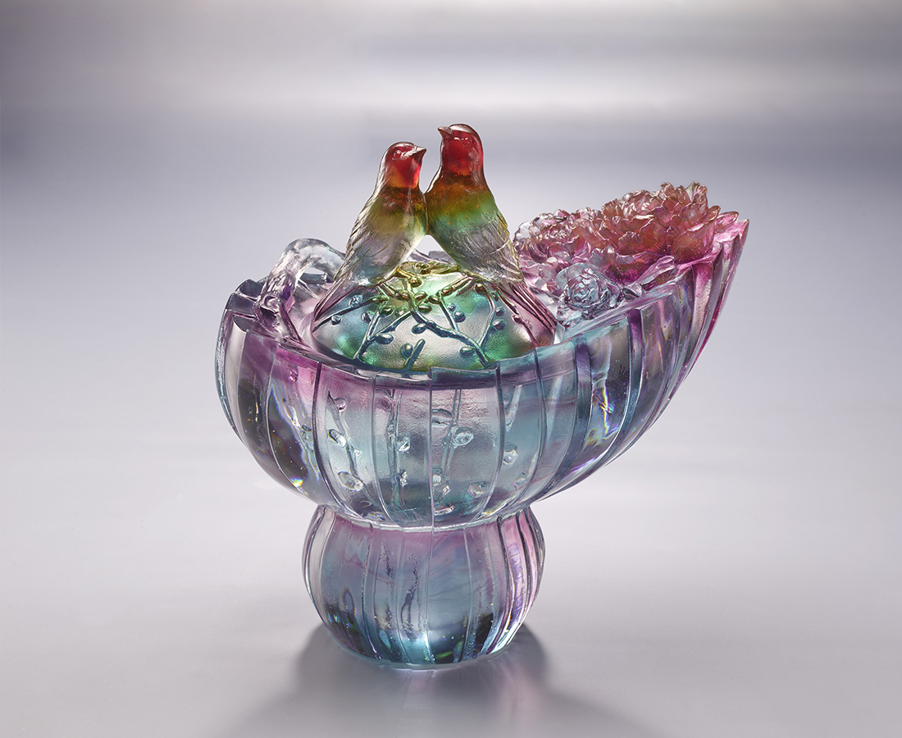
銀柳啼雙，牡丹燦放
為來歲許下晶瑩願望
然後，好好藏收
每一次揭探，喜悅盈滿
Peony Magpie Cornucopia
It is said that the magpie, symbol of fortune, brings good news. Peony, on the other hand, is called the flower of wealth in Chinese. It represents flourishments and prosperity. The cat-tail willow symbolizing money, conveys the joy of welcoming wealth with spring. The artwork combines the magpie, peony, and cat-tail willow to deliver the message of safety and fortune. The design of cornucopia not only shows its message, but is also applicable for daily usage such as storage and decoration.

編號 | 1403907 | No | 1403907
名稱 | 晶喜豐藏 | Name | Peony Magpie Cornucopia
顏色 | 紅琥紫青透 | Color | red, amber, purple, cyan, clear
尺寸 | 19.5 * 13 * 19 | Size | 19.5 * 13 * 19
重量 | 3.5 | Weight | 3.5
限量 | O | Limited Edition | O
售價 | NT$ 26880 | Price | NT$ 26880
 | RMB$ 5980 |  | RMB$ 5980

