晶碧輝煌 | 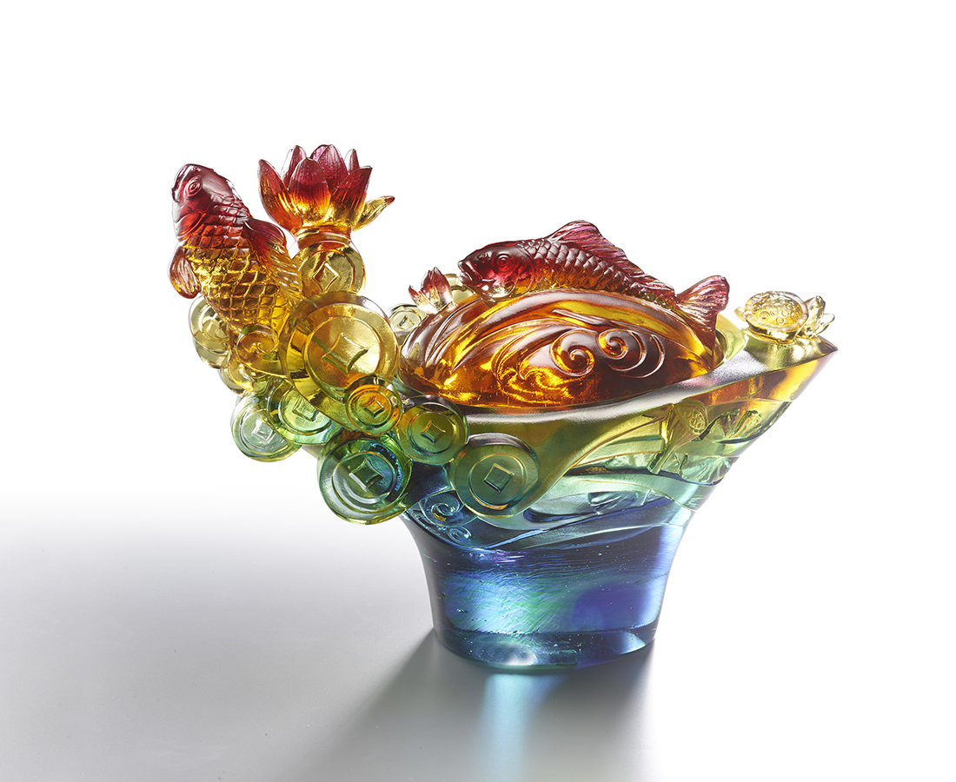
雙鯉逐浪，好荷吐芳
財圓滚滚出金碧輝煌
然後，好好藏收
每一次揭探，福祿綿長
Lotus Carp Cornucopia
The picture of lotus and carp is an ancient Chinese art delivering fortune. The lotus has its Chinese pronunciation similar to “continuity” and “surplus,” representing gradual abundance. The artwork utilizes lotus and carp as central elements, further designed as a cornucopia for daily usage.

編號 | 1403906 | No | 1403906
名稱 | 晶碧輝煌 | Name | Lotus Carp Cornucopia
顏色 | 紅琥藍綠青透 | Color | red, amber, blue, green, cyan, clear
尺寸 | 19 * 12 * 25 | Size | 19 * 12 * 25
重量 | 3.6 | Weight | 3.6
限量 | O | Limited Edition | O
售價 | NT$ 29800 | Price | NT$ 29800
 | RMB$ 6650 |  | RMB$ 6650

