福事 | 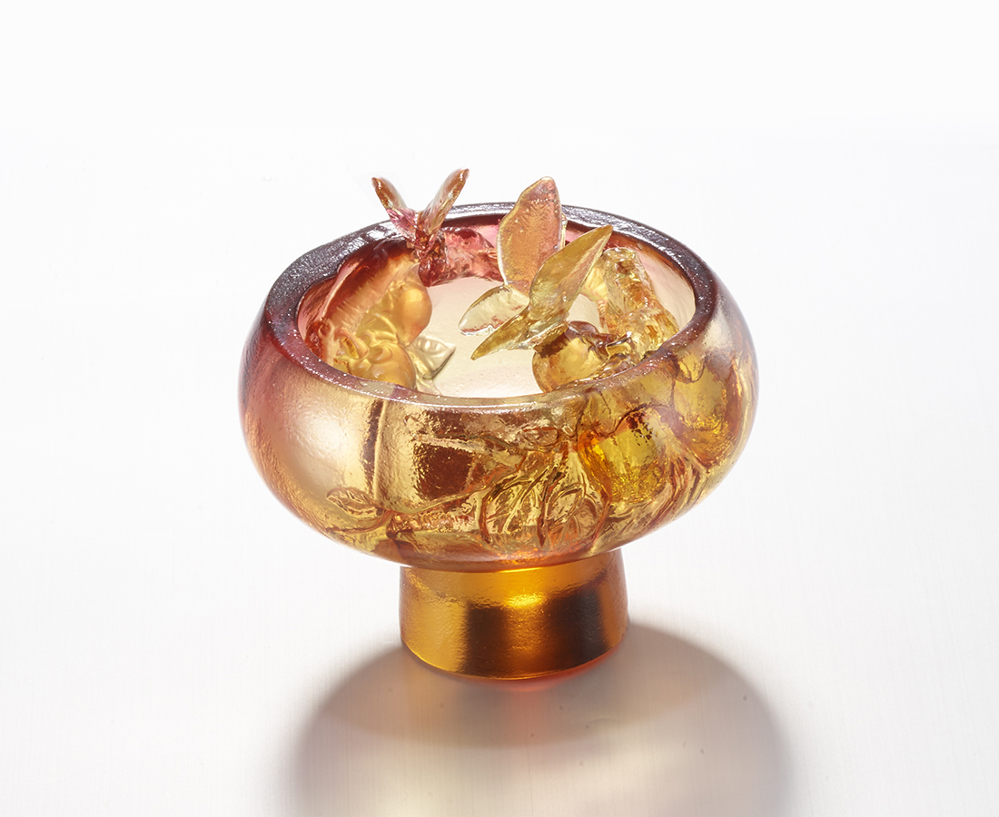
在人海中
打磨得光亮剔透
轉不盡事事如意
圓一個福氣滿園
Persimmon Utensil
It’s made with a persimmon-shaped bowl as the main body, echoing the delicate persimmon carving inside the bowl, with two butterflies on persimmon to add lively interest.

編號 | 1403680 | No | 1403680
名稱 | 福事 | Name | Persimmon Utensil
顏色 | 紅琥透 | Color | red, amber, clear
尺寸 | 8 * 8 * 7.4 | Size | 8 * 8 * 7.4
重量 | 0.27 | Weight | 0.27
限量 | X | Limited Edition | X
售價 | NT$ 4380 | Price | NT$ 4380
 | RMB$ 970 |  | RMB$ 970

