鴻運當頭 | 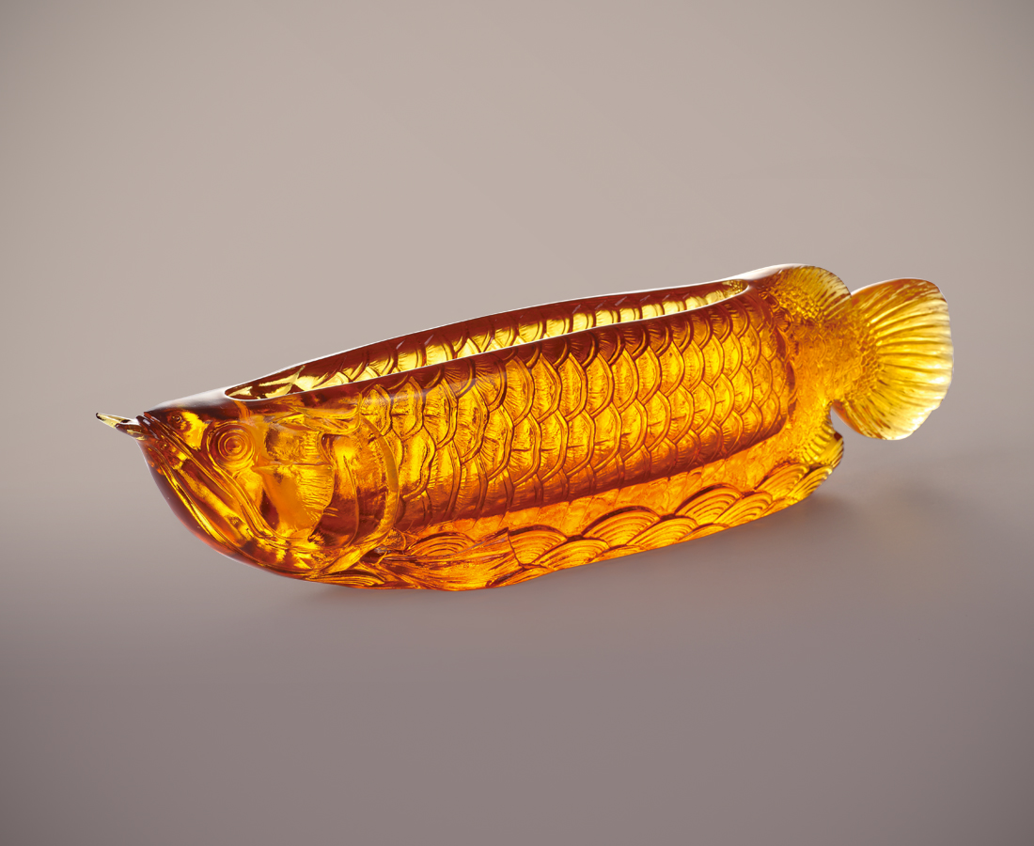
運轉浩蕩澎湃之心
承載千萬年之祈願
風生水起 登堂入室
巍巍而立 鴻運昌隆

Cornucopia of Red Arowana
Asians believe that owning a red arowana can provoke good luck. Tittot combines red dragon and cornucopia, which symbolizes wealth, to bring smoothness to everything in life and good fortune into your door.

編號 | 1403623 | No | 1403623
名稱 | 鴻運當頭 | Name | Cornucopia of Red Arowana
顏色 | 琥 | Color | amber
尺寸 | 46.5 * 8.5 * 10.5 | Size | 46.5 * 8.5 * 10.5
重量 | 4.9 | Weight | 4.9
限量 | O | Limited Edition | O
售價 | NT$ 46800 | Price | NT$ 46800
 | RMB$ 10400 |  | RMB$ 10400

