斟情人生 | 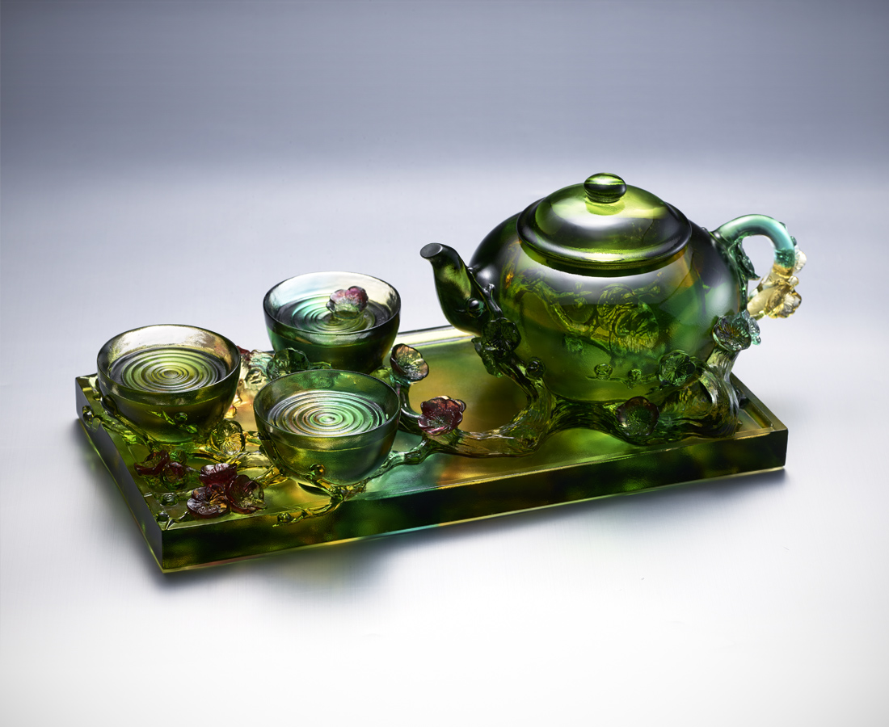
可以撞杯共飲 可以談笑細品
才斟三杯 就熱情滿案
天南忘了地北 古往忘了今來
風流人物穿梭 乾坤又換幾輪
今宵借助月光 抖落羈絆
且話你我夢想 笑傲江湖
情場商場戲場 共享輸贏
小山冷夜梅滿枝
有茶便不冷
Plum Blossom Teapot
In China, there is a poem which said that the same tea, if share with friends, will be more fragrant. Anywhere, getting together in tea party is an important time to maintain friendships. The pleasant atmosphere in the party just likes the flowers twine around the tea in the work, continuing to bloom.

編號 | 1403589 | No | 1403589
名稱 | 斟情人生 | Name | Plum Blossom Teapot
顏色 | 綠紅金琥透 | Color | green , red , golden , amber , clear
尺寸 | 31 * 13.5 * 10.5 | Size | 31 * 13.5 * 10.5
重量 | 3.8 | Weight | 3.8
限量 | O | Limited Edition | O
售價 | NT$ 33600 | Price | NT$ 33600
 | RMB$ 7470 |  | RMB$ 7470

