開泰 ( 小 ) | 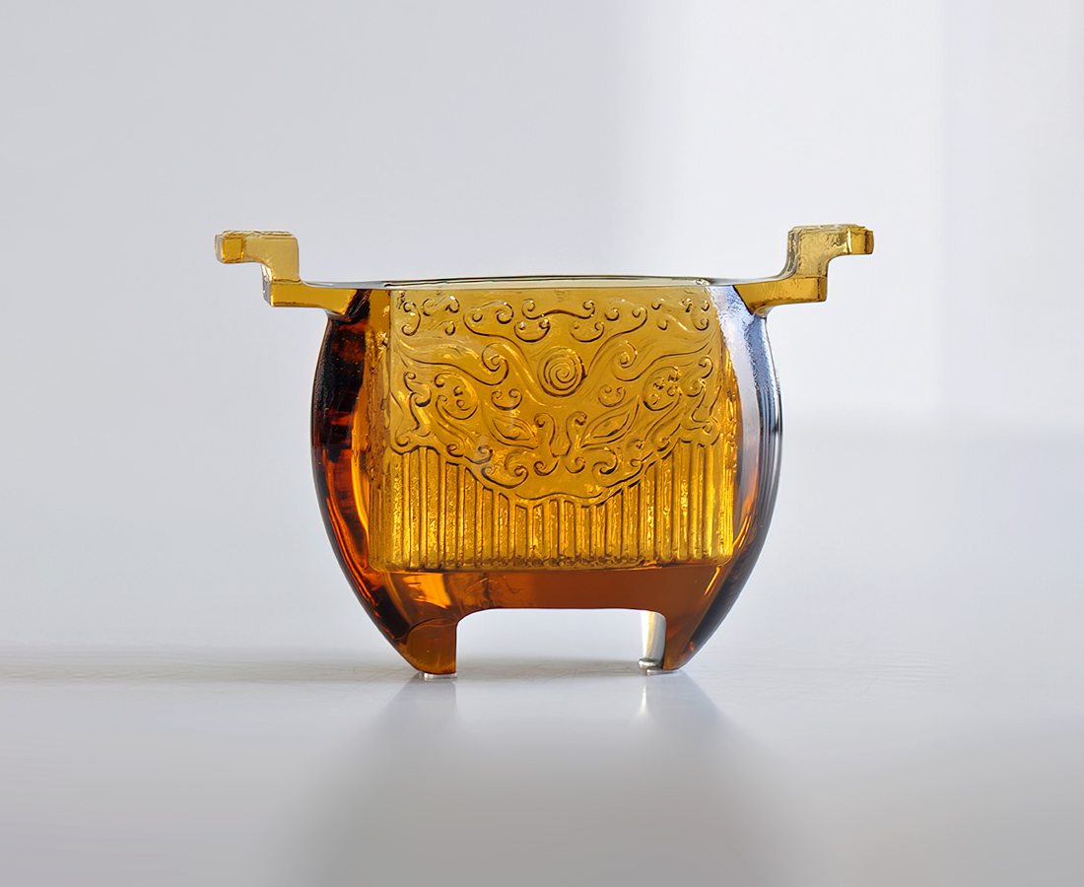
泰然自若的目光
端視深遠的記憶
靜觀變遷的脈絡
而品嚐日新月異的況味
Prosperity
Composed eyes, Contain memory of the past. Observing the trains of changes, Serve to savor the changing situation.

編號 | 1403453 | No | 1403453
名稱 | 開泰 ( 小 ) | Name | Prosperity
顏色 | 茶 | Color | brown
尺寸 | 13.35 * 4.65 * 9.5 | Size | 13.35 * 4.65 * 9.5
重量 | 0.41 | Weight | 0.41
限量 | X | Limited Edition | X
售價 | NT$ 6600 | Price | NT$ 6600
 | RMB$ 1400 |  | RMB$ 1400

