荷諧自得 | 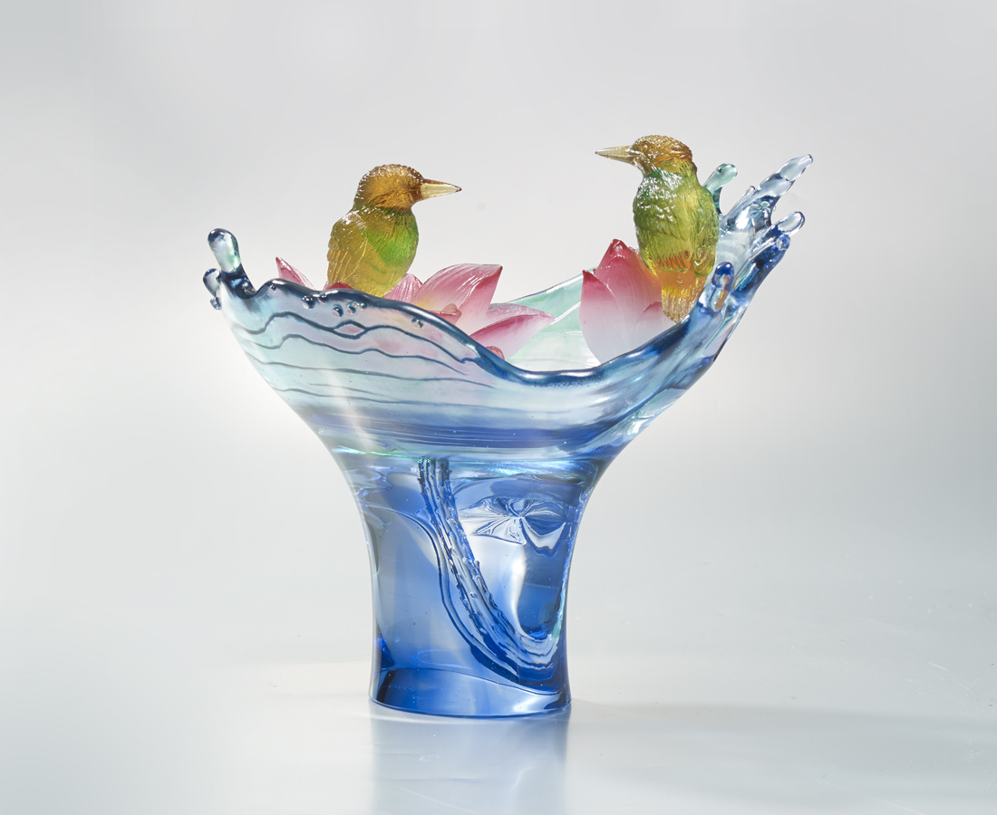
借力使力
就能如鳥般的瀟灑
站穩腳步
就能如荷般的無邪
如水如鏡 洞澈一切
自得優游 和諧坦然
Lotus
Adopting techniques of intaglio, powder sinter and many others, Tittot has perfectly enlivened the shape of the lotus and kingfisher. Contrasts between transparent and opaque, with the carvings beyond and below the water surface, it has made this simple art piece into a wide lotus pond full of oriental aesthetics.

編號 | 1403450 | No | 1403450
名稱 | 荷諧自得 | Name | Lotus
顏色 | 藍綠金琥紅粉透 | Color | blue , green , golden , amber , red , pi
尺寸 | 24.5 * 15 * 23.4 | Size | 24.5 * 15 * 23.4
重量 | 2.7 | Weight | 2.7
限量 | O | Limited Edition | O
售價 | NT$ 36800 | Price | NT$ 36800
 | RMB$ 8180 |  | RMB$ 8180

