乘夢遠航 | 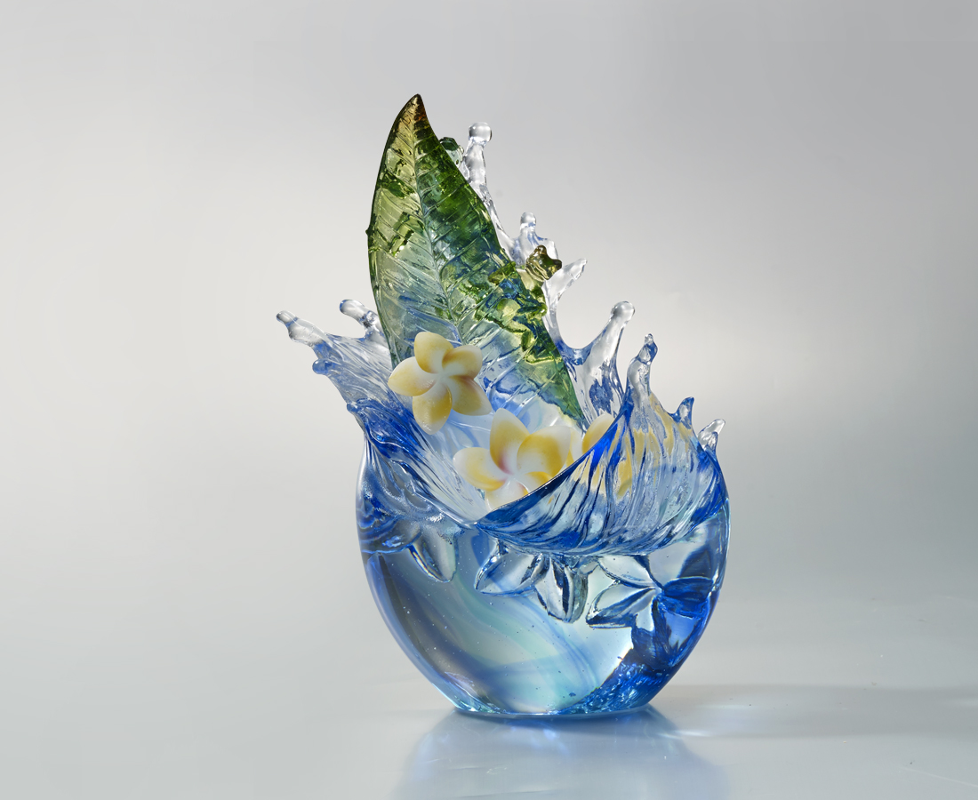
飄洋過海
為了新的希望
引吭高歌
為了新的夢想
有夢
就能超越驚濤駭浪
航向新世界
Plumeria
Plumeria is native to Central and South America, and Dutch traded it and introduced it to Taiwan. Through the Plumeria flower, Tittot wants to express the spirit that as long as we stick to our dreams and face anything unyieldingly, a new world can be created.

編號 | 1403416 | No | 1403416
名稱 | 乘夢遠航 | Name | Plumeria
顏色 | 藍綠琥透 | Color | blue , green , amber , clear
尺寸 | 17 * 12 * 24.1 | Size | 17 * 12 * 24.1
重量 | 2.7 | Weight | 2.7
限量 | O | Limited Edition | O
售價 | NT$ 28800 | Price | NT$ 28800
 | RMB$ 6400 |  | RMB$ 6400

