典雅風範 | 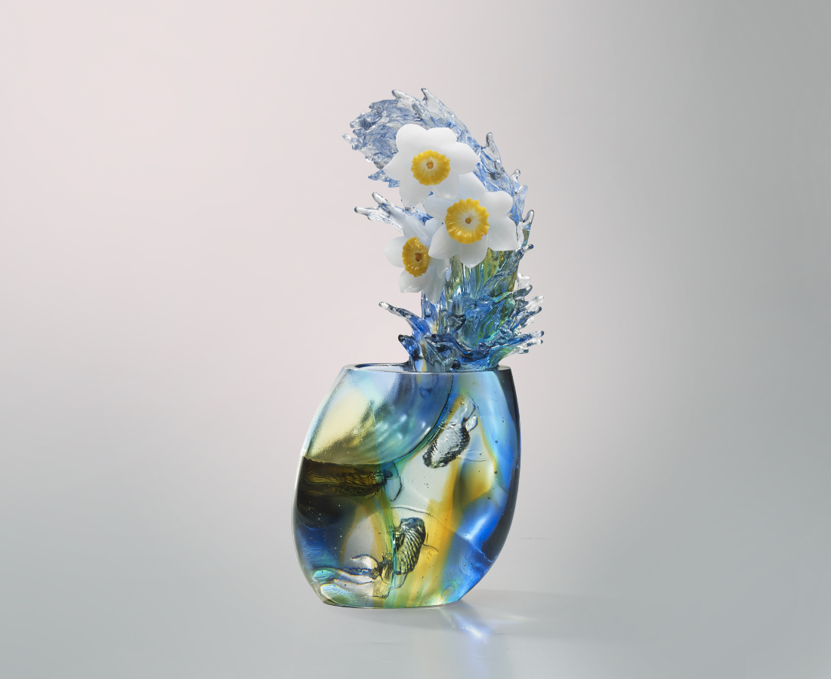
冰肌玉骨 無瑕馨香
身段如水 心思亦如水
交融出你我的真心
激盪成全新的喝采
Daffodil
Tittot gives full play of the glass’ transparency and highlights the clarity of water with an intaglio fish. Multiple contrasts between splashing sprays and elegant daffodils and the tranquil water have created a brand new art level that surpasses general glass art.

編號 | 1403415 | No | 1403415
名稱 | 典雅風範 | Name | Daffodil
顏色 | 藍綠琥透 | Color | blue , green , amber , clear
尺寸 | 16.5 * 11.7 * 33.4 | Size | 16.5 * 11.7 * 33.4
重量 | 5.5 | Weight | 5.5
限量 | O | Limited Edition | O
售價 | NT$ 32800 | Price | NT$ 32800
 | RMB$ 7290 |  | RMB$ 7290

