逐鹿天下 | 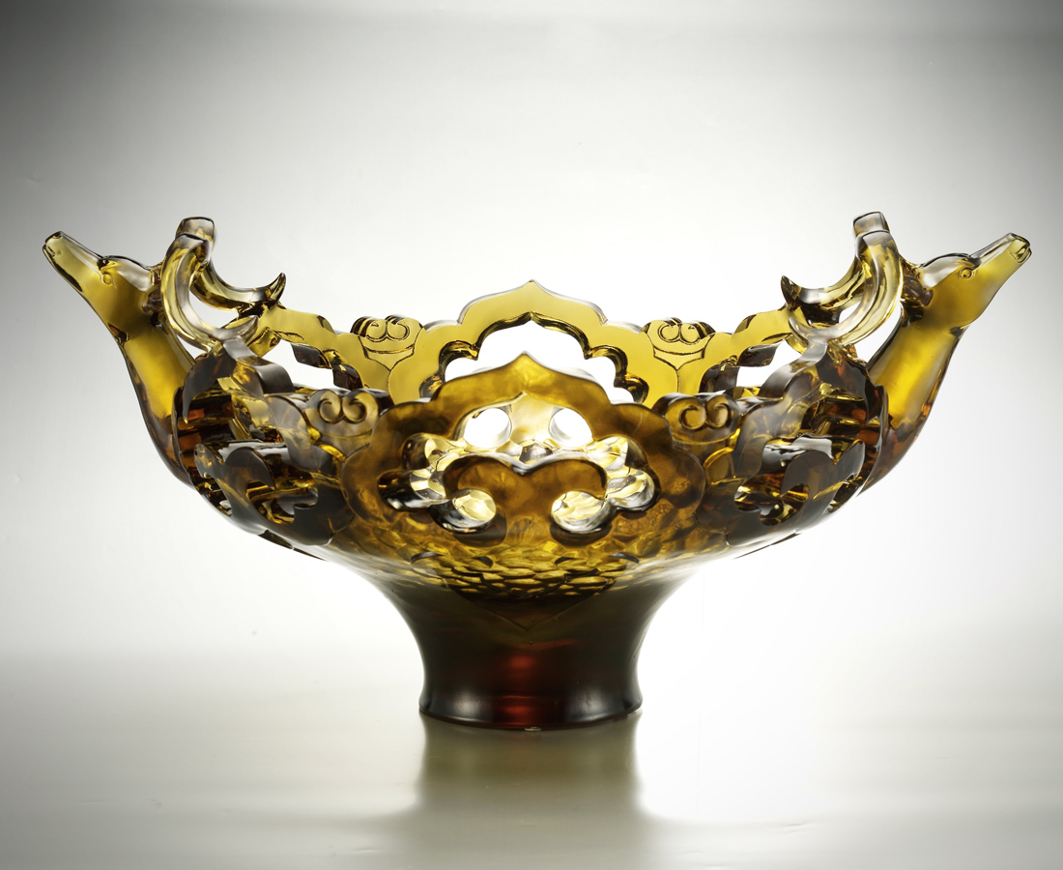
靜以凝神定志 磨礪鋒芒
動以拔地而起 奔躍飛馳
把理想合鳴 把節奏合拍
四方齊發 一路無往不利

Vie for Power in All Areas
Be still to determine one’s will clearly And sharpen one’s ability Be vigorous to rise abruptly, and gallop at wind’s speed Ambitions are concerted in harmonious rhythm The wind is always favorable in whatever direction is taken

編號 | 1403275 | No | 1403275
名稱 | 逐鹿天下 | Name | Vie for Power in All Areas
顏色 | 茶 | Color | null
尺寸 | 38.5 * 53.4 * 30.2 | Size | 38.5 * 53.4 * 30.2
重量 | 18.1 | Weight | 18.1
限量 | O | Limited Edition | O
售價 | NT$ 151800 | Price | NT$ 151800
 | RMB$ 33730 |  | RMB$ 33730

