風行雲天 | 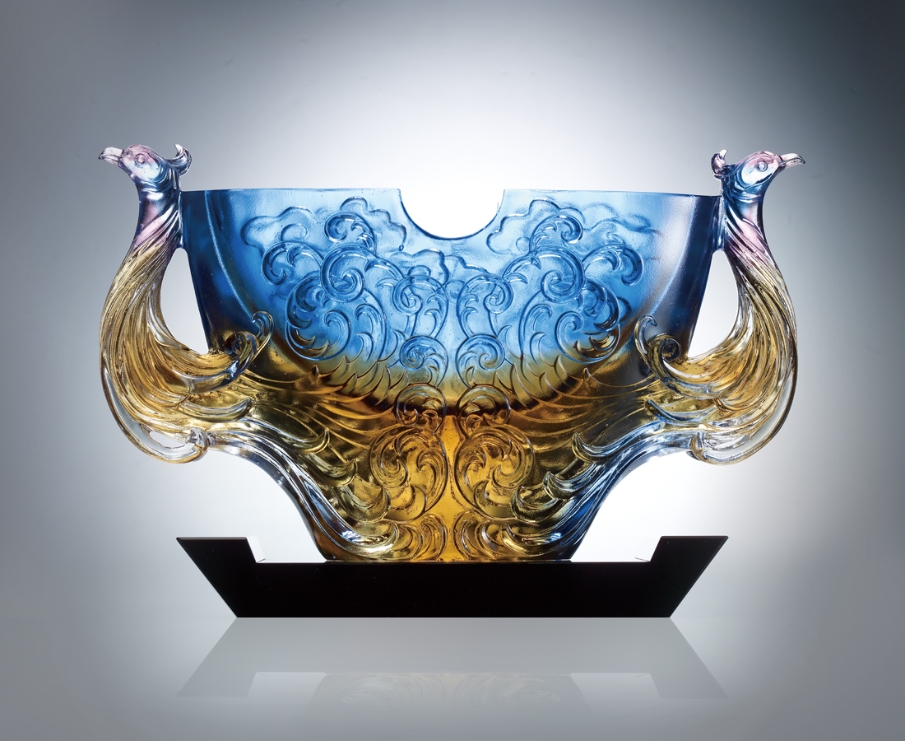
丈量風的速度
穿入光電火石的萬千意象
探向天的氣度
振飛山高海闊的凌雲壯志
浩然風行八方 大放異彩
The Breakthrough Phoenix
Traveling at the speed of the wind Penetrating the ever-changing light and images Touching the limits of heaven And flying higher than the mountains and covering oceans afar Overwhelming in all directions, shining like the sun

編號 | 1403247 | No | 1403247
名稱 | 風行雲天 | Name | The Breakthrough Phoenix
顏色 | 琥藍紫透 | Color
尺寸 | 8.4 * 29 * 16.5 | Size | 8.4 * 29 * 16.5
重量 | 3.7 | Weight | 3.7
限量 | O | Limited Edition | O
售價 | NT$ 28800 | Price | NT$ 28800
 | RMB$ 6600 |  | RMB$ 6600

