蓮連有餘 | 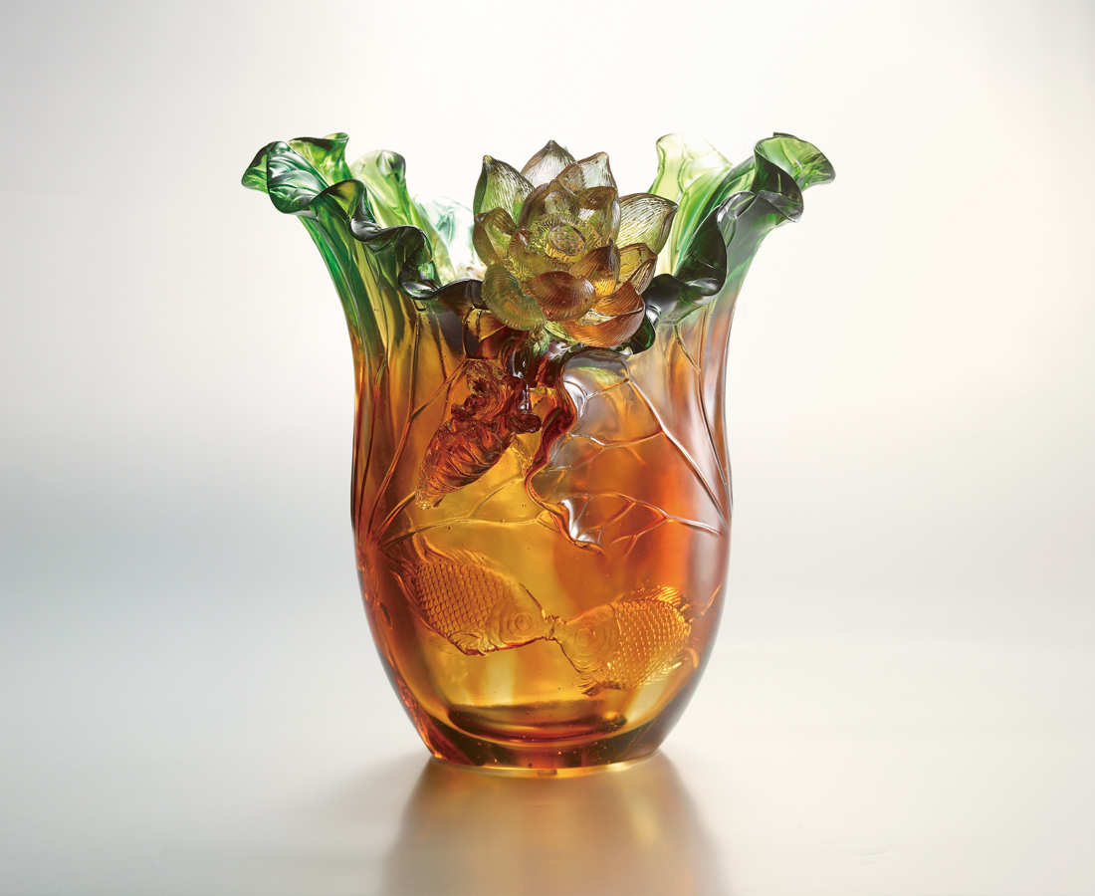
絲絲緊扣你的關愛
時時荷風香遠益清
我心剔透 我福無邊
換個方向 轉個圈圈
天天花開 年年魚慶
Linked Lotuses in Abundance
Locking tightly with your caring Breezes traveling afar with Lotus fragrance Crystal clear is my heart, and my joy endless Switching my directions to circle my realm Where years are always abundant Flowers always blossom

編號 | 1403244 | No | 1403244
名稱 | 蓮連有餘 | Name | Linked Lotuses in Abundance
顏色 | 琥綠紫透 | Color
尺寸 | 28.7 * 26.3 * 29.7 | Size | 28.7 * 26.3 * 29.7
重量 | 8.12 | Weight | 8.12
限量 | O | Limited Edition | O
售價 | NT$ 43800 | Price | NT$ 43800
 | RMB$ 10000 |  | RMB$ 10000

