九如圖 | 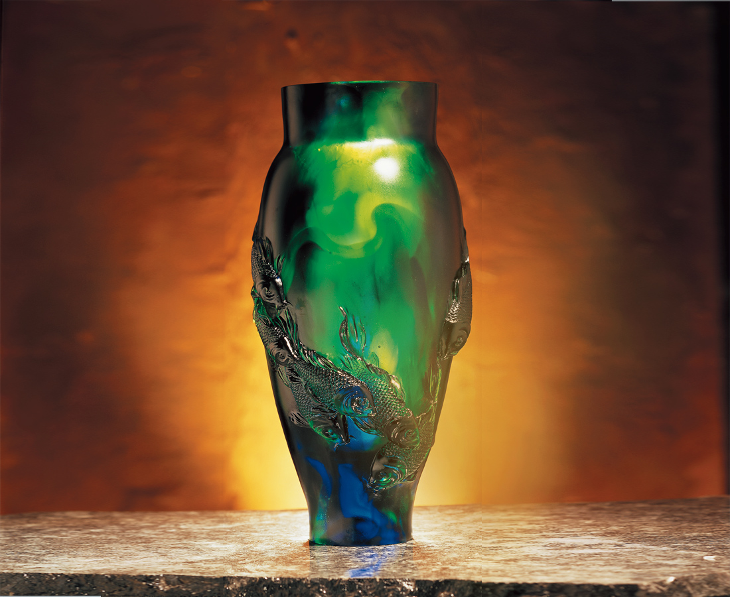
飽滿堅實的瓶身
肥碩悠遊的魚兒
一幅“如魚得水”
滿足而幸福的景象
此作品以厚實高大的形式
和精細優美的鯉魚造型來傳達
魚兒魚兒水中游
游來游去樂融融
萬事平安 萬事如意
As Nine Pictures
A substantial bottle like body A big and fleshy sauntering little fish A scene of contentment and happiness as a fish in water This works depth and lofty form With exquisite meticulousness transmits an exquisite carp shape Little fish little fish swimming in the water happily back and forth All is peaceful may all be as you wish

編號 | 1403126 | No | 1403126
名稱 | 九如圖 | Name | As Nine Pictures
顏色 | 藍綠透 | Color
尺寸 | 19 * 19 * 40 | Size | 19 * 19 * 40
重量 | 29.0 | Weight | 29.0
限量 | O | Limited Edition | O
售價 | NT$ 296000 | Price | NT$ 296000
 | RMB$ 58310 |  | RMB$ 58310

