蒸蒸日上 | 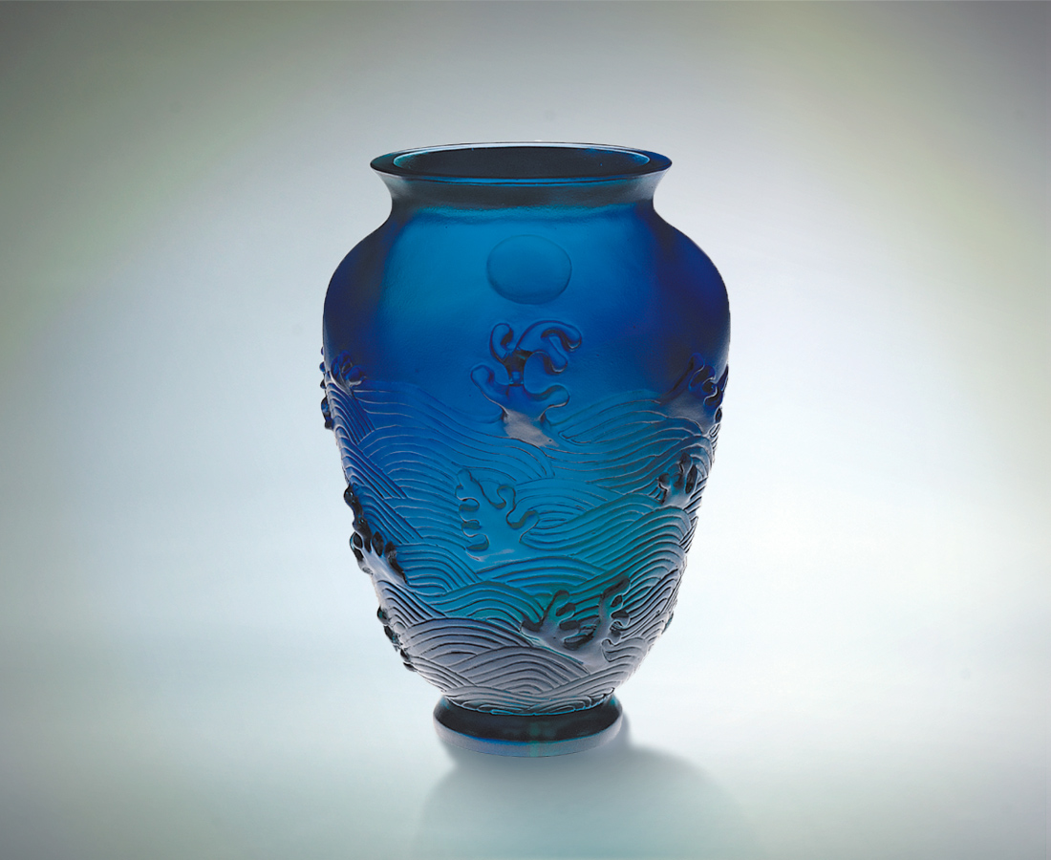
澎湃湧起的浪花
冉冉高升的太陽
交織成一幅神聖而動感的場面
這是宇宙生命本質的意象
不斷升高 不斷進步 不停激盪
海水和太陽相互激勵
我們也以此相互祝福、期許
蒸蒸日上
永不休止
The Blazing Sun
The roaring waves, and sun creeping ever higher: these two merge to create a sacred and moving tableau that imparts the very life of the universe. Always climbing onward, always moving ahead, stirring without rest: the sun and sea surge in unison. We blessed with this vision of unity, hope that the blazing sun will never cease its journey.

編號 | 1403101 | No | 1403101
名稱 | 蒸蒸日上 | Name | The Blazing Sun
顏色 | 藍綠透 | Color
尺寸 | 12.2 * 11.6 * 16.3 | Size | 12.2 * 11.6 * 16.3
重量 | 1.3 | Weight | 1.3
限量 | O | Limited Edition | O
售價 | NT$ 21800 | Price | NT$ 21800
 | RMB$ 5388 |  | RMB$ 5388

