湧往直上 | 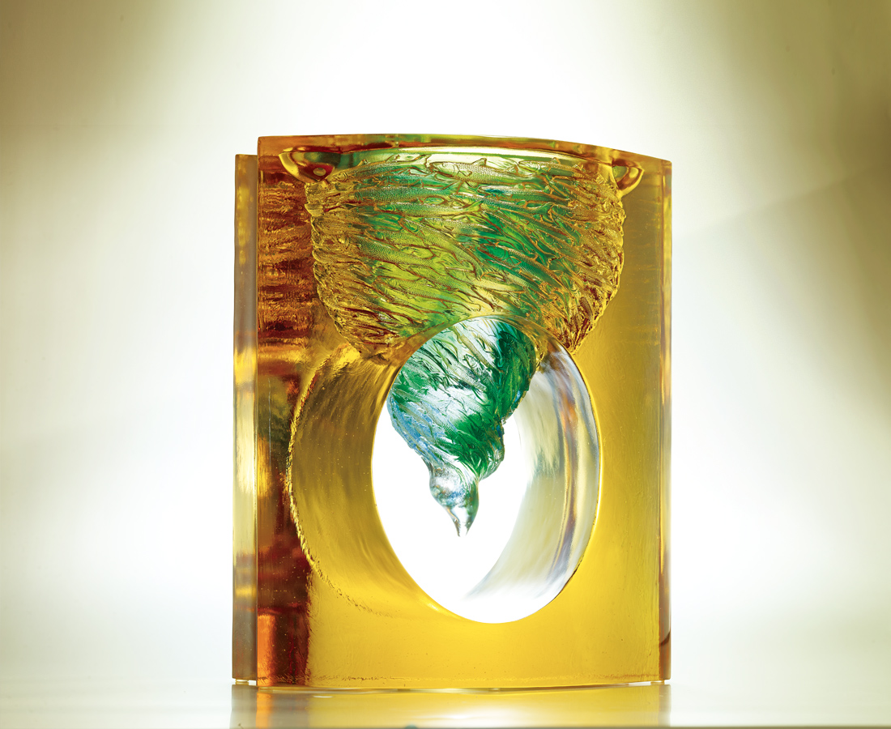
把豪情呼嘯成風
把夢想狂飆成歌
席捲湧往直上的熱情
燦爛志在功成的光采
Against All Odds
The spiraling whirlwind of aspiration The fervent song of ambition Inspiring passion to drive forward Against all odds The glory of success shall be forthcoming

編號 | 1402911 | No | 1402911
名稱 | 湧往直上 | Name | Against All Odds
顏色 | 外件:金+內件: 藍綠青透 | Color
尺寸 | 18 * 27.8 * 35 | Size | 18 * 27.8 * 35
重量 | 25.6 | Weight | 25.6
限量 | O | Limited Edition | O
售價 | NT$ 226600 | Price | NT$ 226600
 | RMB$ 50380 |  | RMB$ 50380

