滿庭春 | 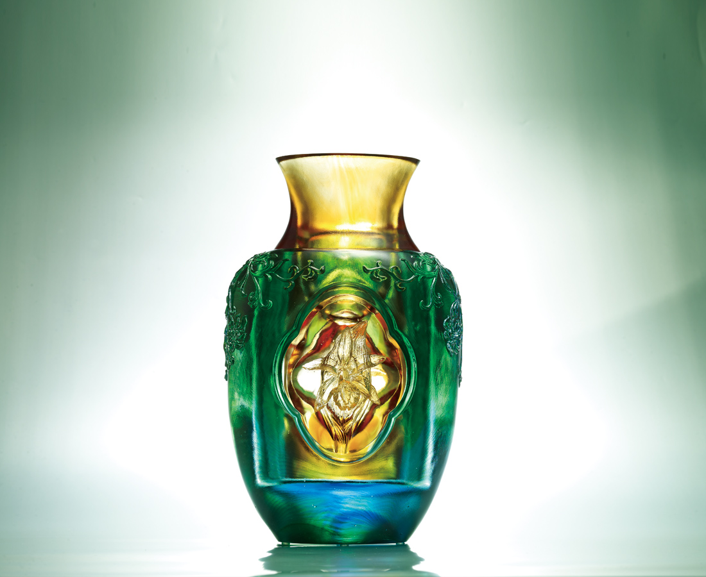
一花一葉
洞見堅毅不拔的希望
一心一意
透露怡然自得的信心
必然迎向陽光燦爛時
Spring Garden
Single flower with single leaf Transpires optimism of unwavering persistence Single heart with single intension Exudes confidence of contentment Through such dedication and determination Ultimate success shall be within reach

編號 | 1402908 | No | 1402908
名稱 | 滿庭春 | Name | Spring Garden
顏色 | 外瓶:藍綠青透+內膽:金琥透 / 外瓶: | Color
尺寸 | 13.4 * 20 * 32.4 | Size | 13.4 * 20 * 32.4
重量 | 7.9 | Weight | 7.9
限量 | O | Limited Edition | O
售價 | NT$ 76800 | Price | NT$ 76800
 | RMB$ 17080 |  | RMB$ 17080

