豐華鼎盛 | 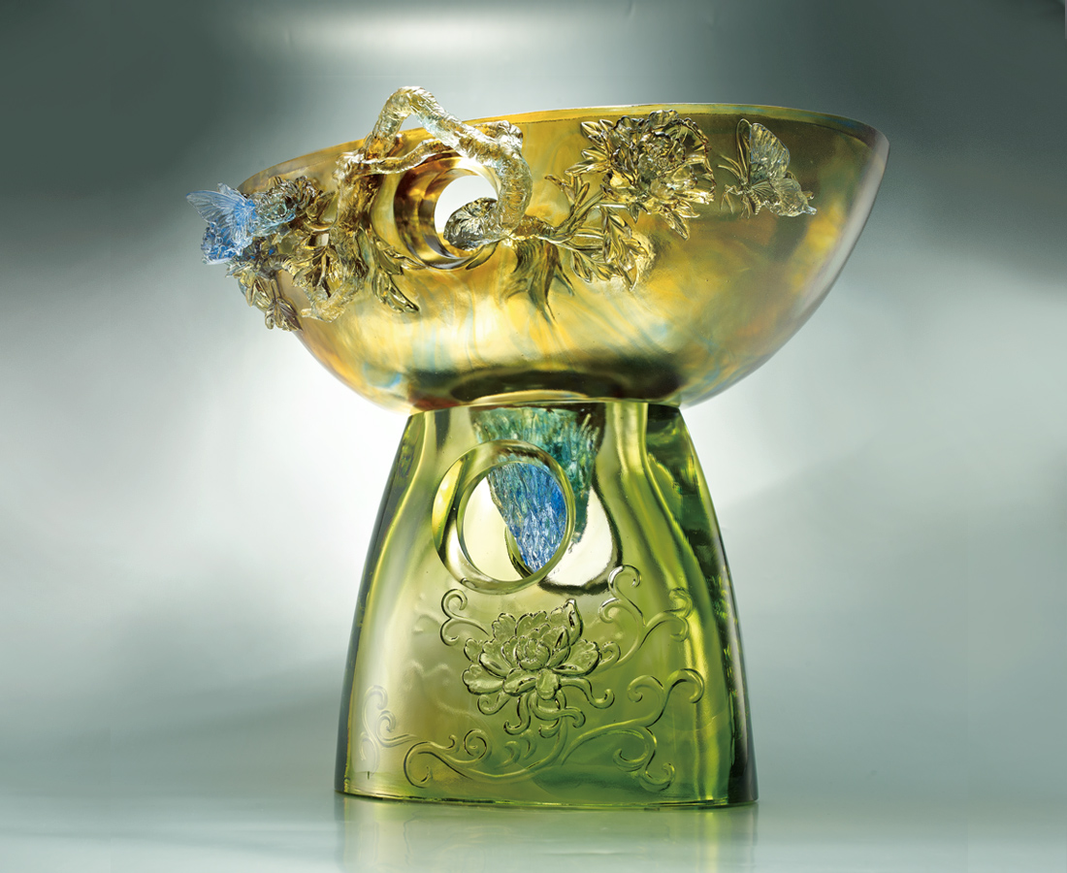
灌滿春的信心盪漾
渲染光的蓬勃熱情
把裡裡外外都盛放
最昂揚豐碩的燦爛
State of Prosperity
Exuberating with the confidence of spring Adorned with the blossoming passion of light The flourishing state of prosperity Permeates the resplendent atmosphere

編號 | 1402901 | No | 1402901
名稱 | 豐華鼎盛 | Name | State of Prosperity
顏色 | 上座:金藍透+下座: 金綠透 | Color | null
尺寸 | 33 * 45 * 41.8 | Size | 33 * 45 * 41.8
重量 | 26.0 | Weight | 26.0
限量 | O | Limited Edition | O
售價 | NT$ 402000 | Price | NT$ 402000
 | RMB$ 89400 |  | RMB$ 89400

