自信 | 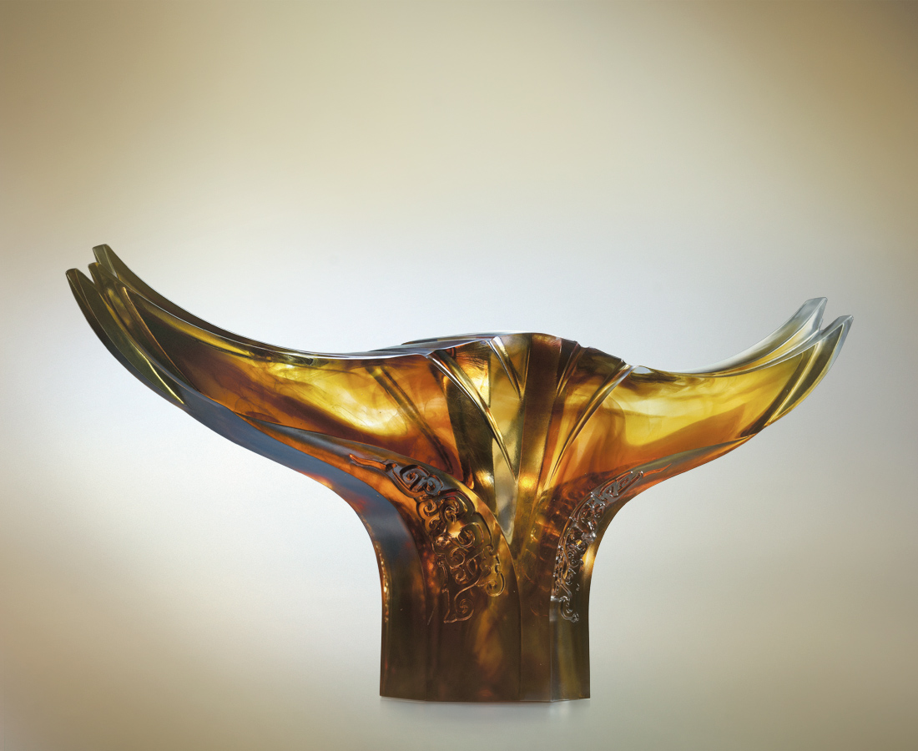
洞悉於內 通達於外
放空才能放開的架式
有豁然優雅的平衡
無限可塑的自由
Self Confidence
Perceive the truth from yours within For confidence unveils itself Empty thy heart that it can receive As vase is full it holds not Rid of prejudice that balance returns Freedom unlimited if wisdom learned

編號 | 1402738 | No | 1402738
名稱 | 自信 | Name | Self Confidence
顏色 | 茶琥透 | Color
尺寸 | 11.6 * 52.5 * 26 | Size | 11.6 * 52.5 * 26
重量 | 11.3 | Weight | 11.3
限量 | O | Limited Edition | O
售價 | NT$ 140800 | Price | NT$ 140800
 | RMB$ 32000 |  | RMB$ 32000

