乘豐而上 | 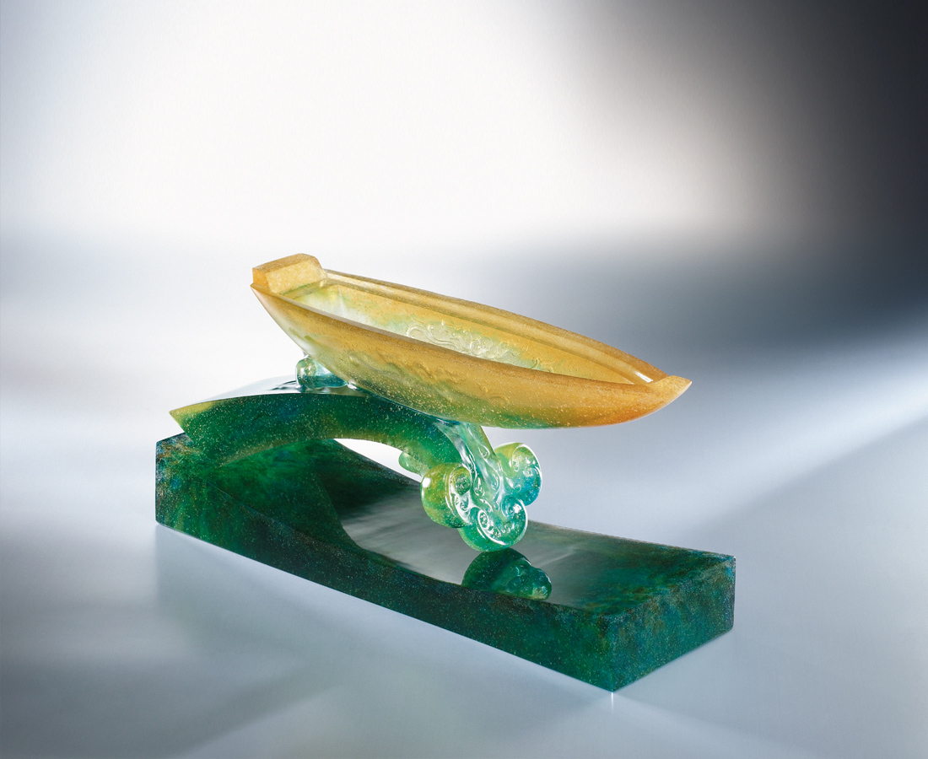
往豐饒之海航
向開闊世界行
撒網信心 裝滿希望
乘風衝上如意的浪頭
Windfall In The Sail
To fathomless wealth her anchor aweigh To the vast open world meet with fate Have faith nets shall cast, in hope a catch of best In full sail it rides the good will crest

編號 | 1402727 | No | 1402727
名稱 | 乘豐而上 | Name | Windfall In The Sail
顏色 | 琥綠藍青透 | Color
尺寸 | 9.5 * 30 * 14 | Size | 9.5 * 30 * 14
重量 | 4.5 | Weight | 4.5
限量 | O | Limited Edition | O
售價 | NT$ 29980 | Price | NT$ 29980
 | RMB$ 7520 |  | RMB$ 7520

