淨思 | 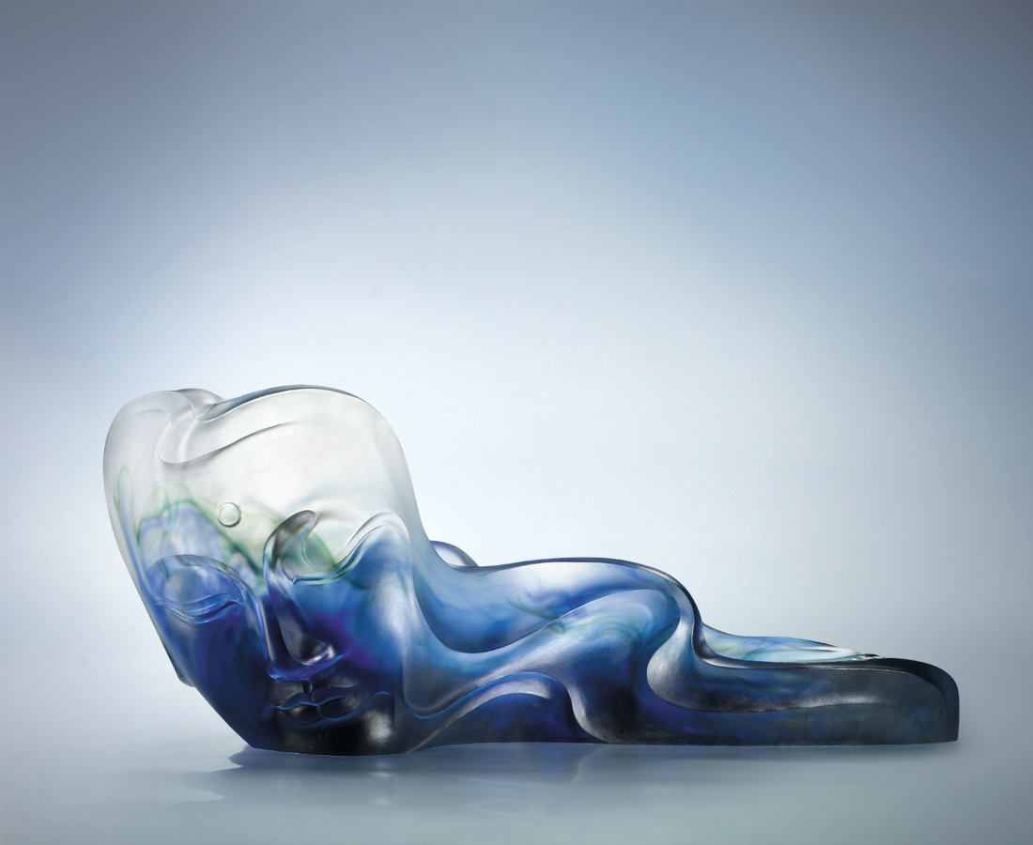
隨心寂靜之流
遨遊萬物之外
隨風隨水 廣闊無邊
人間是淨土
As Buddha's Thought
With solitude my heart silently flows Like Buddha, I hold my own With wind and water, free as ever As everywhere is my fairyland

編號 | 1402703 | No | 1402703
名稱 | 淨思 | Name | As Buddha's Thought
顏色 | 透 / 藍青透 | Color
尺寸 | 50.5 * 27.5 * 20.8 | Size | 50.5 * 27.5 * 20.8
重量 | 13.5 | Weight | 13.5
限量 | O | Limited Edition | O
售價 | NT$ 158000 | Price | NT$ 158000
 | RMB$ 39600 |  | RMB$ 39600

