春風 | 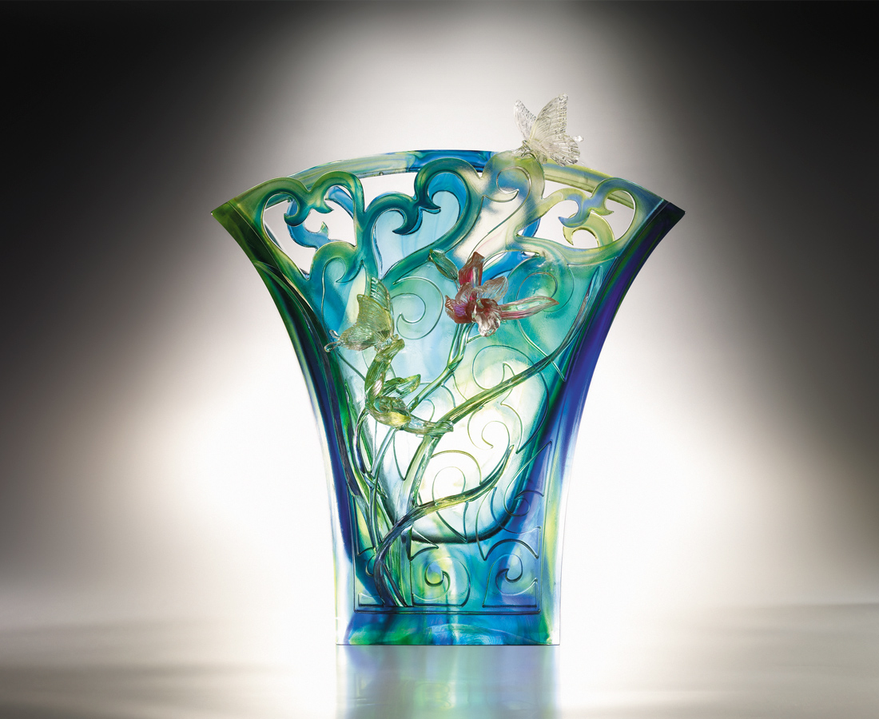
似從風裡飛來
如從幽蘭吐出
來去應時順勢
自然春風滿面
Spring Time Breeze
To orchid butterfly dances Awaken to the fragrance Or with the breeze it chances Perhaps, it’s only a mirage of orchid scent Come as it may, leaves as it please Go with the flow, miss not the spring time breeze

編號 | 1402673 | No | 1402673
名稱 | 春風 | Name | Spring Time Breeze
顏色 | 藍綠青琥紅透 | Color | null
尺寸 | 33.8 * 40 * 15.6 | Size | 33.8 * 40 * 15.6
重量 | 12.0 | Weight | 12.0
限量 | O | Limited Edition | O
售價 | NT$ 239800 | Price | NT$ 239800
 | RMB$ 59440 |  | RMB$ 59440

