六合尊貴 | 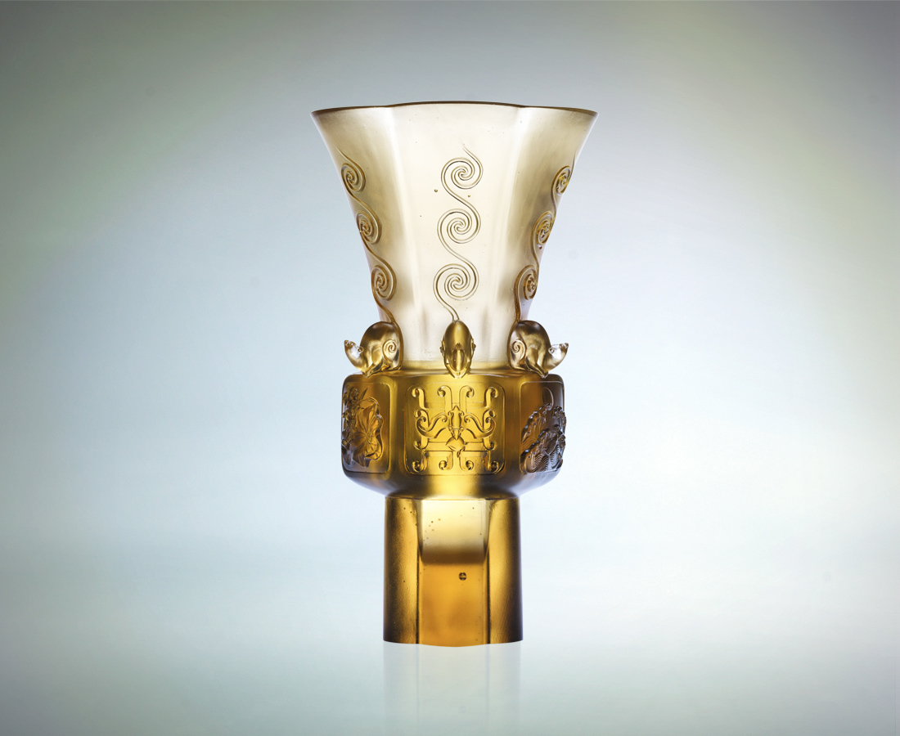
升起尊貴的幸福夢想
踩踏周延的平安步驟
揮動智慧 緊盯方向
目標近了
把握和諧原則
福祿壽喜財旺
必然
六六聚集 環繞久久
Six Royalty Elements
Conjure the dreams of royalty March the steps of peace Advocate wisdom and focus For the goal is near Grasp the principles of harmony The six elements Will then Come together in a lasting spiral

編號 | 1402596 | No | 1402596
名稱 | 六合尊貴 | Name | Six Royalty Elements
顏色 | 茶金 | Color
尺寸 | 16.7 * 15.5 * 28.5 | Size | 16.7 * 15.5 * 28.5
重量 | 4.84 | Weight | 4.84
限量 | O | Limited Edition | O
售價 | NT$ 49800 | Price | NT$ 49800
 | RMB$ 12466 |  | RMB$ 12466

