鴻祿頂天 | 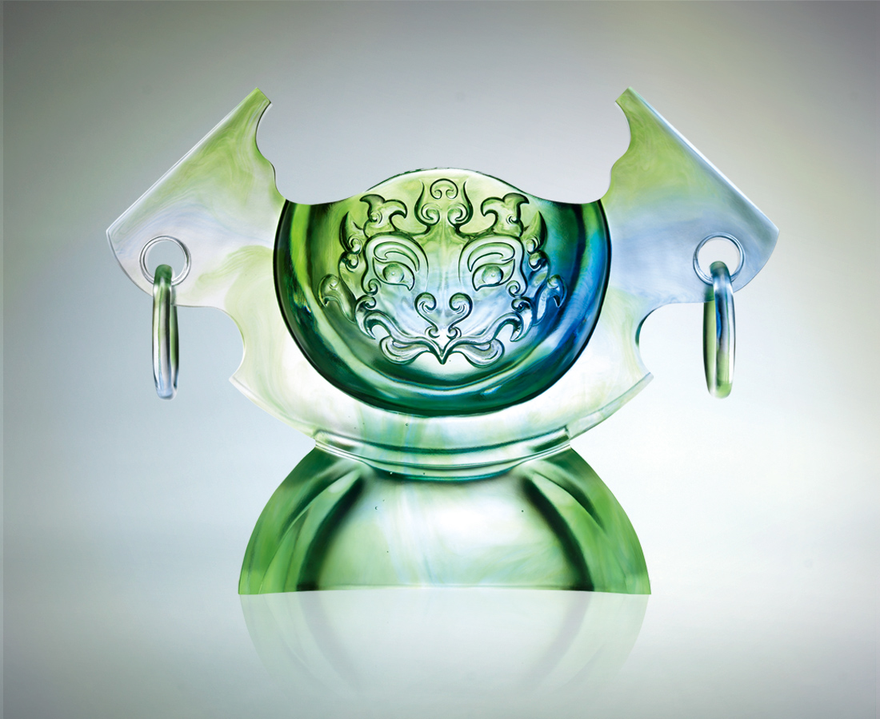
眼光獨到 明察秋毫
創意紛飛 幻化無邊
開創新猷 頂天立地
環扣祿的膽識
勇於突破 承先啟後
精益求精 跨越時空
高舉一世風騷
Thundering Prosperity
With eyes keen and just And an ever-evolving creativity Reign over a new world With the courage of the prosperous Overcome the obstacles For betterment through time And drink to a lifetime of excellence

編號 | 1402524 | No | 1402524
名稱 | 鴻祿頂天 | Name | Thundering Prosperity
顏色 | 藍綠透 | Color
尺寸 | 16 * 45 * 34 | Size | 16 * 45 * 34
重量 | 15.0 | Weight | 15.0
限量 | O | Limited Edition | O
售價 | NT$ 236000 | Price | NT$ 236000
 | RMB$ 58988 |  | RMB$ 58988

