康莊萬里 | 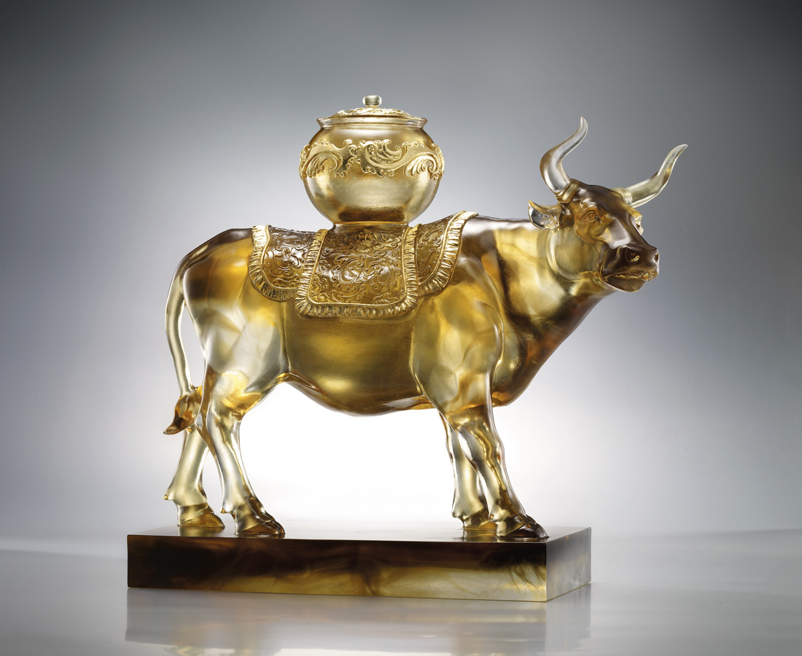
腳踏實地真理
恆久不變
春耕夏耘豐收
認真不懈
見識日積月累
行動堅實有力
步步康莊萬里
A Long Sturdy Road
On solid earth the truth sustains Everlasting shall it remain What the spring sown summer showers Till harvest no time for the flowers Through many moons wisdom gains Act in faith and strength, fears no pain Onto a long road ahead, straight and bright

編號 | 1402523 | No | 1402523
名稱 | 康莊萬里 | Name | A Long Sturdy Road
顏色 | 茶金透 | Color
尺寸 | 15.7 * 37 * 33.5 | Size | 15.7 * 37 * 33.5
重量 | 11.8 | Weight | 11.8
限量 | O | Limited Edition | O
售價 | NT$ 168000 | Price | NT$ 168000
 | RMB$ 42000 |  | RMB$ 42000

