雍容 | 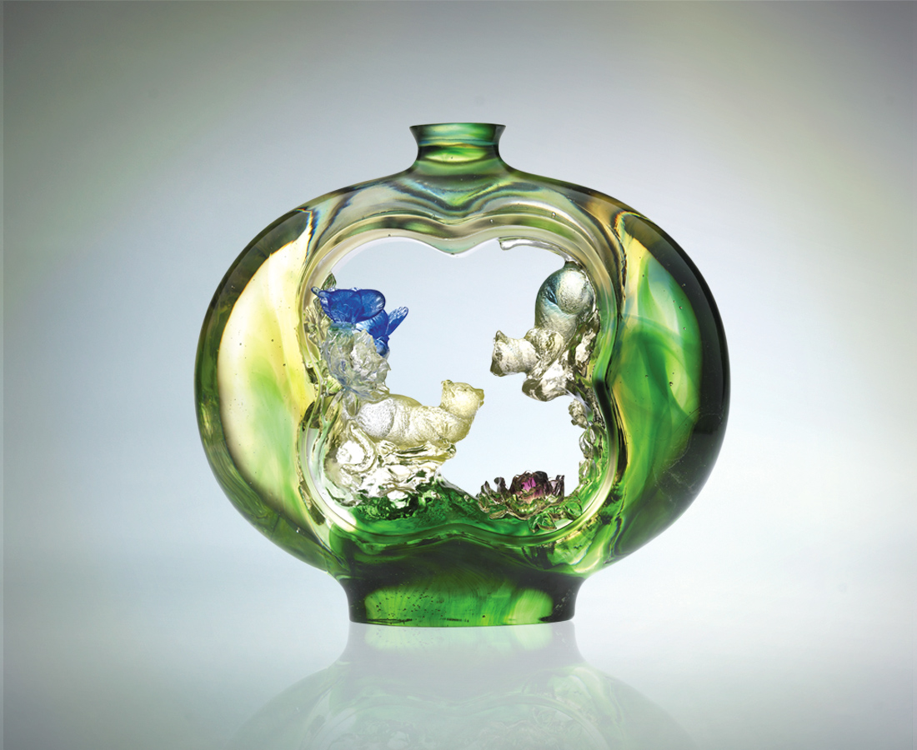
至真至誠
最輕最柔
徐徐高漲
慢慢飽滿
自然必然的
雍容豐采
Refinement
The very sincerity As well as Most gentle manner Accumulated day by day That lead spontaneously to Elegance and refinement

編號 | 1402506 | No | 1402506
名稱 | 雍容 | Name | Refinement
顏色 | 茶金青綠透 | Color
尺寸 | 9 * 25 * 23 | Size | 9 * 25 * 23
重量 | 5.92 | Weight | 5.92
限量 | O | Limited Edition | O
售價 | NT$ 58600 | Price | NT$ 58600
 | RMB$ 12466 |  | RMB$ 12466

