拔得頭籌 | 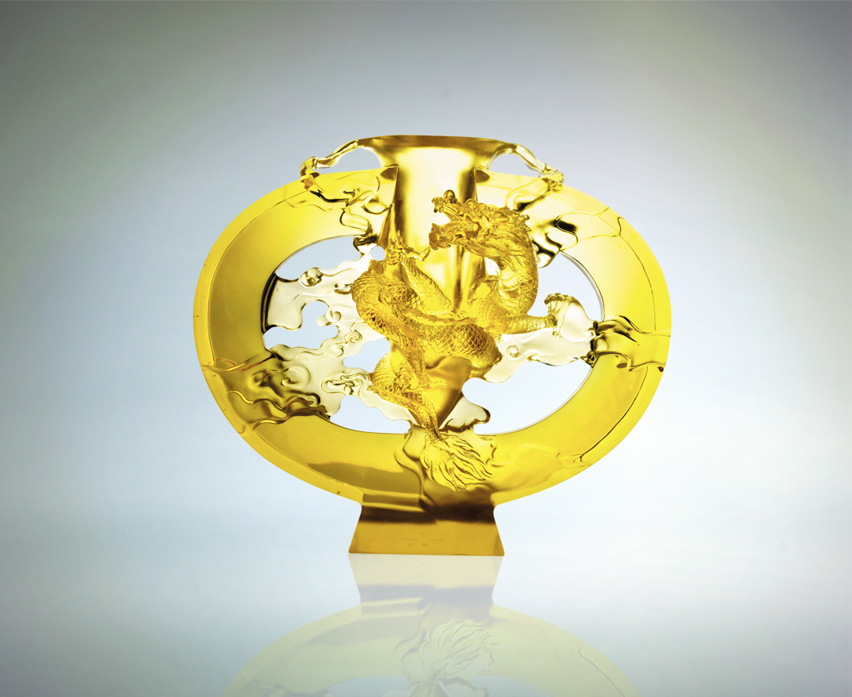
一柱擎天的氣勢
轉乾坤 動風雲
上天下地 行雲流水
永遠高瞻遠矚
始終先聲奪人
而直上雲霄拔得頭籌
Born To Lead
Like a pillar supporting the universe It commands all in heaven and earth Seek far ahead and sow the seed Never look back and keep your lead

編號 | 1402473 | No | 1402473
名稱 | 拔得頭籌 | Name | Born To Lead
顏色 | 金色 | Color
尺寸 | 12.4 * 34.5 * 29.8 | Size | 12.4 * 34.5 * 29.8
重量 | 9.8 | Weight | 9.8
限量 | O | Limited Edition | O
售價 | NT$ 152460 | Price | NT$ 152460
 | RMB$ 31488 |  | RMB$ 31488

