清甜 | 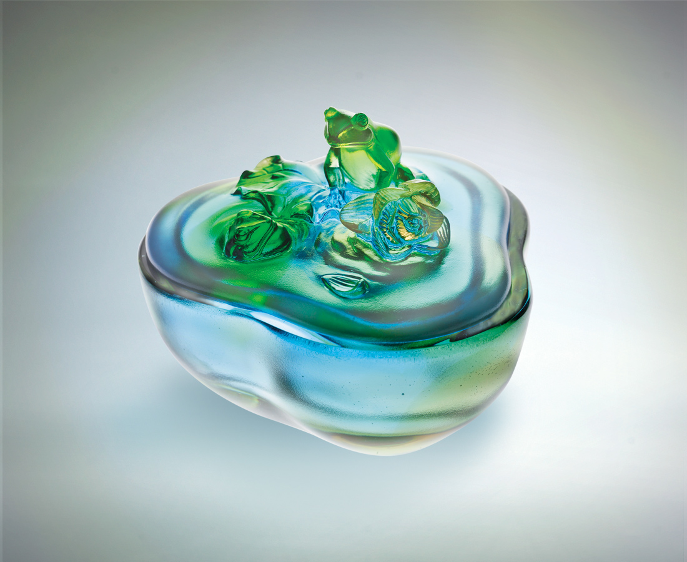
少一點欲望
多一點精神
荷葉瀟灑
荷風堂堂
一路清香遠播
Pure Sweetness
A little less desire A little more energy Elegance of the lotus leaves Upright with the breeze And fragrance traversing far

編號 | 1402432 | No | 1402432
名稱 | 清甜 | Name | Pure Sweetness
顏色 | 粉綠青藍琥透 | Color | pink, green, cyan, purple, blue, amber, clear
尺寸 | 9.1 * 9.4 * 7.4 | Size | 9.1 * 9.4 * 7.4
重量 | 0.5 | Weight | 0.5
限量 | X | Limited Edition | X
售價 | NT$ 5380 | Price | NT$ 5380
 | RMB$ 1366 |  | RMB$ 1366

