春暖滿緣 | 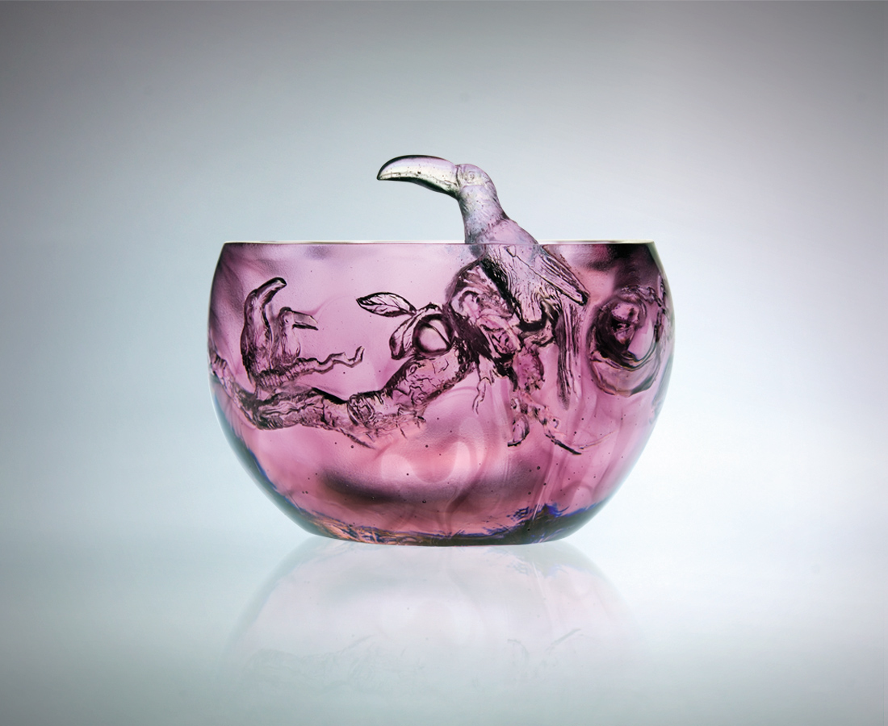
綿延日日月月
身段曲曲折折
感受 生命的恆動
成長的企圖 創新的勇氣
步步扎深 處處結緣
終於 豐碩厚實
而春天 更深刻
Warm Spring, Rich Destiny
Nurtured through time and tide Faced with diverse challenges Experience the vitality of life Eager for growth, ready to create Building depth at every step, enhancing relationships always Eventually gaining a stronghold And Spring comes alive

編號 | 1402419 | No | 1402419
名稱 | 春暖滿緣 | Name | Warm Spring, Rich Destiny
顏色 | 紫粉透青 | Color | purple, pink, cyan, clear
尺寸 | 14.4 * 17.2 * 12 | Size | 14.4 * 17.2 * 12
重量 | 2.36 | Weight | 2.36
限量 | O | Limited Edition | O
售價 | NT$ 15680 | Price | NT$ 15680
 | RMB$ 3922 |  | RMB$ 3922

