秋高如意 | 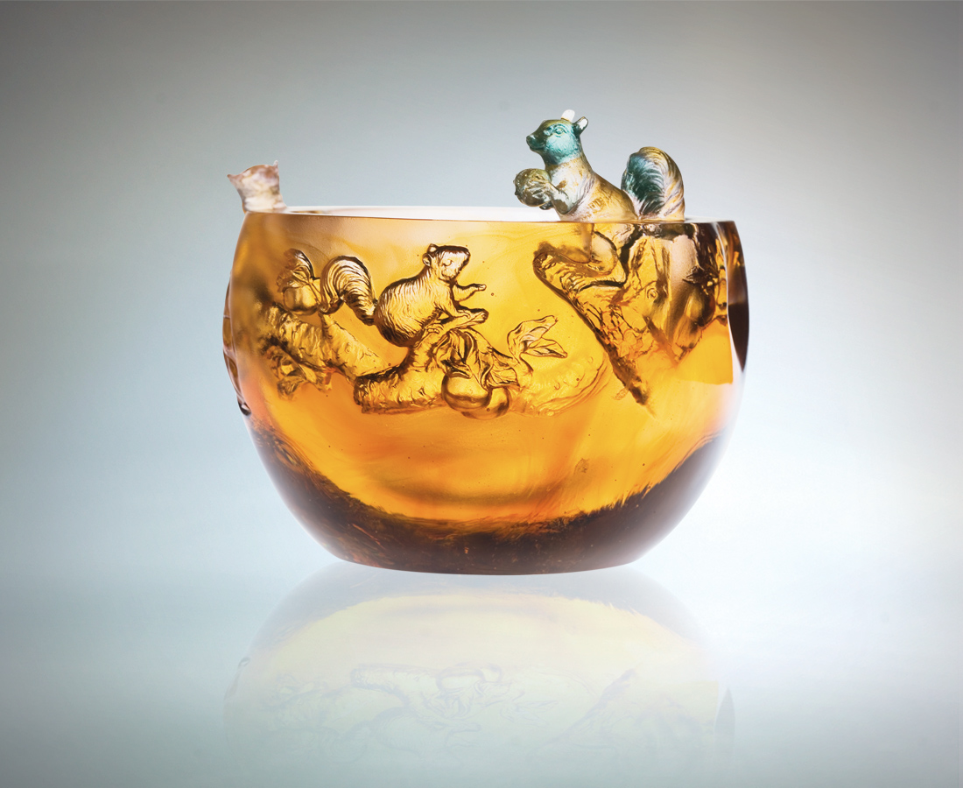
謙遜為懷 實地而做
承默默耕耘之後
啟事事如意之先
互信互諒 情深意厚
群策群力 喜見高峰
而秋天 更剔透
Autumn High
Modesty and common sense Hard work and unwavering determination A prelude to unprecedented success Enriching relationships with mutual trust and patience Achieving success through teamwork and unity So delicate an Autumn

編號 | 1402418 | No | 1402418
名稱 | 秋高如意 | Name | Autumn High
顏色 | 琥綠透粉 | Color | amber, green, pink, clear
尺寸 | 14.1 * 14.5 * 12 | Size | 14.1 * 14.5 * 12
重量 | 2.32 | Weight | 2.32
限量 | O | Limited Edition | O
售價 | NT$ 15680 | Price | NT$ 15680
 | RMB$ 3922 |  | RMB$ 3922

