冬享事成 | 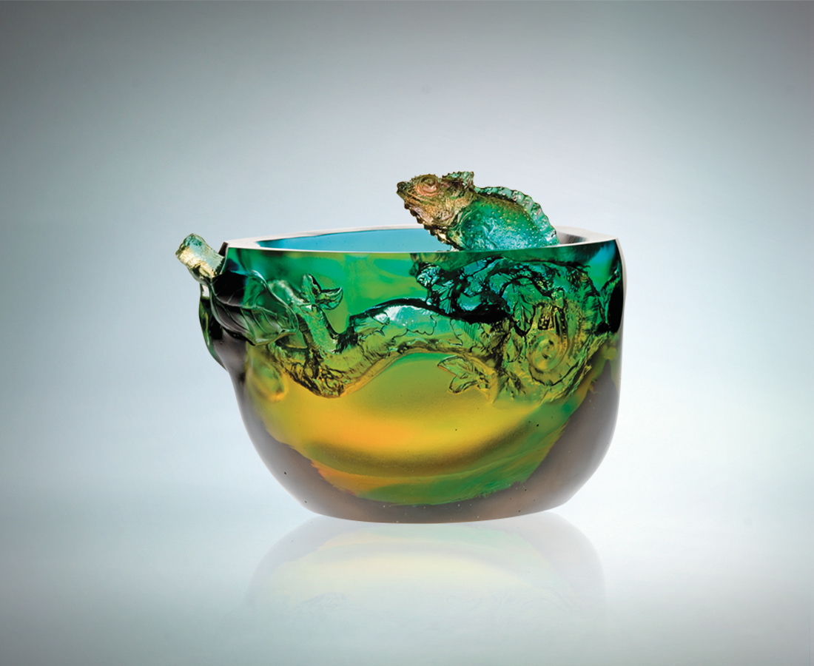
終於心想事成
守住這一刻高潮
回味這一路見聞
敏銳觀察 伺機而動
或高或低隨身變
或甜或酸隨心轉
永遠深思熟慮握先機
而冬天 更晶瑩
Winter’s Success
With success in sight Riding on an all-time high We recall the lessons learnt With keen observation, grasping opportunities Changing with the situation Facing every challenge, success or failure Always focused, never missing an opportunity Sparkling in the Winter

編號 | 1402417 | No | 1402417
名稱 | 冬享事成 | Name | Winter’s Success
顏色 | 琥綠青透紫 | Color | amber, green, cyan, purple, clear
尺寸 | 14 * 15 * 12 | Size | 14 * 15 * 12
重量 | 2.44 | Weight | 2.44
限量 | O | Limited Edition | O
售價 | NT$ 15680 | Price | NT$ 15680
 | RMB$ 3922 |  | RMB$ 3922

