花好月圓 | 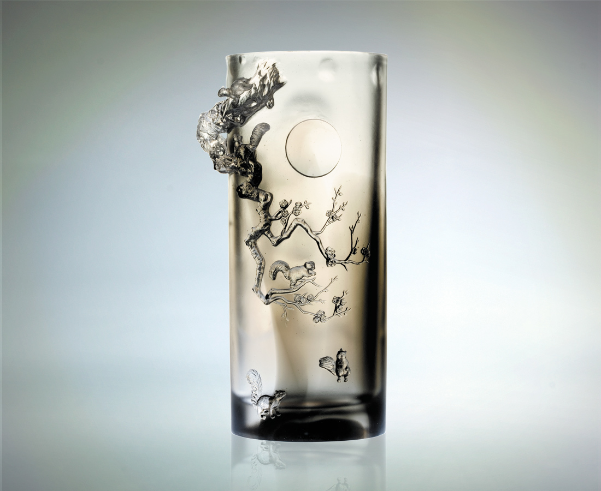
雪月 眼神明亮
冷靜思緒 觀照堅忍
風花 無限繽紛
綻放熱忱 承先啟後
冬去春來有陰晴節奏
理性感性要動靜有序
以合宜神情關注聆聽
人生悠揚頓挫的旋律
而高奏花好月圓樂章
Happy Endings
The radiant moon, emanating luminous light With deep calm thoughts, encouraging perseverance The natural landscape, exuding exuberant beauty With passion and sincerity, driving order Spring follows winter in a definitive pattern Actions pertaining to objectivity and emotions are balanced Complying with the moods and careful listening The sweet melody of life and living

編號 | 1402327 | No | 1402327
名稱 | 花好月圓 | Name | Happy Endings
顏色 | 灰透 | Color | gray,clear
尺寸 | 10.2 * 14.6 * 29.2 | Size | 10.2 * 14.6 * 29.2
重量 | 3.76 | Weight | 3.76
限量 | O | Limited Edition | O
售價 | NT$ 36800 | Price | NT$ 36800
 | RMB$ 9188 |  | RMB$ 9188

