今生典藏 | 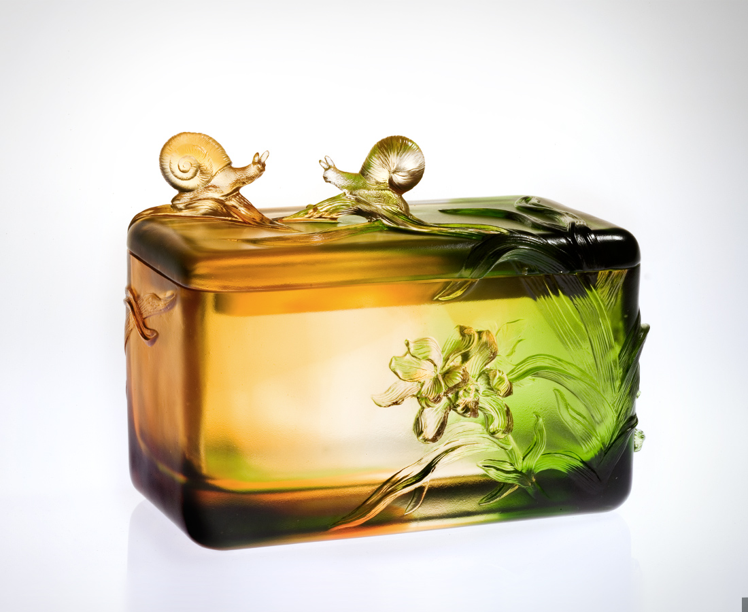
尋幽香的蹤跡
探訪花開的智慧
綻放自信 清新自在
循和緩的節奏
步上深刻的因緣
進退有節 喜樂交織
分享悠然自得的開闊
典藏相契相合的芬芳
謹為回味細膩的歲月
神聖收放
Hidden Treasures
Following the traces of fragrance Searching for intellectual bloom Emanating confidence in purity and freedom With perfect harmony Treading destiny’s path Every step measured, thriving in happiness Sharing the openness and tranquility Shielding the joy of oneness Reliving details of the past Treasuring them forever

編號 | 1402317 | No | 1402317
名稱 | 今生典藏 | Name | Hidden Treasures
顏色 | 琥綠透 | Color | amber, green,clear
尺寸 | 10 * 16.7 * 12.9 | Size | 10 * 16.7 * 12.9
重量 | 1.9 | Weight | 1.9
限量 | O | Limited Edition | O
售價 | NT$ 19800 | Price | NT$ 19800
 | RMB$ 4688 |  | RMB$ 4688

